/$Jalc)a1<v>

c4trs*

he Official Publication otALOA—An International Assficiation of Security Professionals

PLUS!

Uhat Can NRSTF Do For Vou? ireg Perry and the CD-X09 'JELL)! Locksmith Crossword Puzzle ind MORE!

*\*\*#**$%**$###$jy*

BRECKH. CAMPCML PO BOX 47070 ATLANTA GA 30362-0070

I..11.11 Il..ll....l.lll.„ll.,.l.,.lll...l...lll 1,11

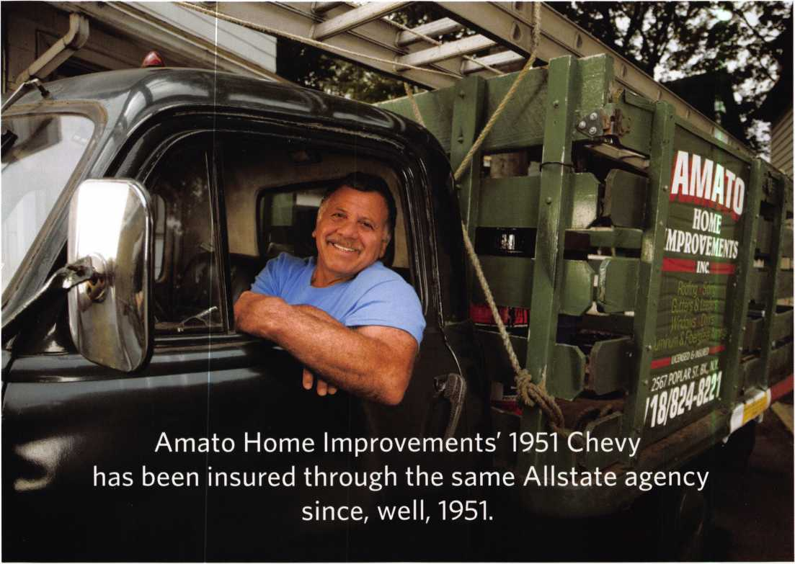

y

rears ago, Joe Amatos father  
bought a commercial vehicle

policy from Allstate Agent  
Ralph Borsella. Today, Ralph  
Borsella, Jr., services the policy,  
and Joe runs the family business.  
Through many years and two  
generations9 their business  
relationship is still going strong.  
Just like Joes ’51 Chevy.

**ALLSTATE AGENTS VALUE LONG-TERM  
CUSTOMERS AS MUCH AS YOU DO.**

Our agents understand the unique needs of business  
owners like you. Because they're business owners, too.  
They'll help you get the insurance that's right for your  
business at a competitive price. And if you need to file a  
claim, they'll help you get back on the road fast. When  
your livelihood relies on your vehicle, you need coverage  
you can rely on. That's Allstate's Stands

Call now to save on Allstate Commercial Vehicle Insurance.

FOR AN ALLSTATE AGENT NEAR YOU, CALL 1-888-322-3078

You're in good hands.

***Auto Home Life Retirement***

Subject to availability and qualifications. Life insurance and annuities issued by Allstate Life Insurance Company, Northbrook, IL and Lincoln Benefit Life Company, Lincoln, NE. In New York, Allstate Life Insurance Company of New York, Hauppauge, NY. Property-casualty insurance products issued by Allstate Fire and Casualty Insurance Company, Allstate Indemnity Company, Allstate Insurance Company, Allstate Property and Casualty Insurance Company, Allstate County Mutual Insurance Company, Irving, TX and Allstate New Jersey Insurance Company, Bridgewater, NJ. © 2007 Allstate Insurance Company

3

You Can Become an AIOA

REGISTERED

LOCKSMITH

Donl Miss this Class!

The ALOA Continuing Education (ACE)

6-day Basic Locksmithing Course will provide  
you with basic hands-on knowledge of locks  
and security related hardware. Students will  
work with a basic locksmithing tool kit that in-  
cludes the following: 4-way screwdriver, soft  
face mallet, dial calipers, combination Tru-Arc  
pliers, pin tumbler tweezers, plug follower, pin  
tray, shims, impressioning pliers, pippin file,  
flat file, lock pick set and universal pin tumbler  
pinning kit.

Upon completion of this course, you will have the knowledge required to  
function as an apprentice locksmith who can perform the following tasks:

* identify and duplicate keys,
* service and adjust key machines,
* rekey a variety of lock cylinders,
* make original keys for a variety of  
  locks; by code, disassembly and  
  impressioning,
* bypass and/or pick common locks,
* troubleshoot and service common  
  cylinder and lockset malfunctions,
* identify common lock hardware fin-  
  ishes and functions,
* 'be familiar with Life Safety Codes  
  and the ADA,
* design and key a simple master  
  key system,
* know combination lock operation and changing methods,

Students Receive:

* llco Key Blank Directory
* PRP Resource Guide which includes the ALOA Locksmith Dictionary
* A fully illustrated 561-page reference manual.
* A Life Safety Codes & ADA class manual
* An ACE Certificate attesting 48 credit hours of CE instruction.
* An RL certificate will be issued to those who successfully pass the  
  written test at the end of the course.

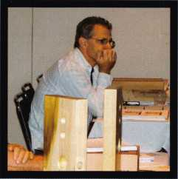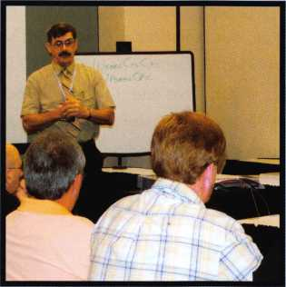

\

N

Register1Now

for December  
2007

■ Class

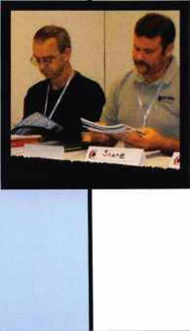

Course Dates:

(Class Hours are 8am - 5pm daily)  
•December 3 -8,2007  
March 10-15,2008  
August 18-23,2008  
December 1-0,2008

Class location:

ALOA Training Center  
3500 Easy Street  
Dallas, TX 75247

Price:

$ 005.00 for AIOA members  
$1190.00 for non members

To Register Contact:

ALOA Education Department  
3500 Easy Street  
Dallas, TX 75247  
P-800-532-2562 X101  
F-214-819-9429

Email:

[education@aloa.org](mailto:education@aloa.org) Website: [www.aloa.org](http://www.aloa.org)

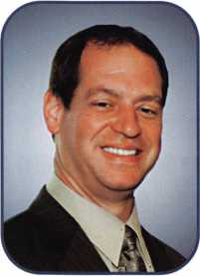

Happy Thanksgiving:

Thanks. I hope each of you is thankful for what this industry has given us: a livelihood, friend-  
ships, knowledge and a sense of accomplishment; among many other things.

Giving. Now that we are thankful for what we have, it is time to give back to the industry that  
has given to us. It is never too early to start thinking about running for an ALOA board position or  
even a position in your local association. These organizations need help. It is usually a very small  
group that does the workload for many. Join in and help. This year our election process has been  
moved up two months to accommodate an early convention, and to make it easier for members  
out of the country to vote, send in your nomination form now.

Theft is not a subject that many like to talk about but affect our customers every day. There are staggering statistics on how employee theft far outweighs any other kind of theft and can be one of the leading causes of why businesses fail. There is an article about how one business owner wanted to have a CCTV system installed in his business, so he could catch cus­tomers stealing from him. Once the system was installed, he soon discovered it was his trusted employees that were the major problem. I actually had a friend of mine tell me he took equipment and supplies from his previous employer because "they owed it to him." I guess giving him a well-paying job with benefits for 20 years was not enough. We are all in busi­ness to help our customers solve security issues. If you have never installed a CCTV system, take some classes and learn all about this part of our industry; it could be very lucrative.

Every month I will end my message with a request from you, our members. If you have a suggestion that you think will make ALOA better and stronger, please email them to me at [president@aloa.org](mailto:president@aloa.org) or mail to PO Box 17944 Tampa FL 33682-7944. Please be sure to include your name and member number, if you have one. I will not respond except to acknowledge that I have received your suggestion (if by email). I will consider every suggestion and see to it that appropriate action is taken. Please make sure to read the summary and minutes of the next meeting to find the outcome of your suggestion.

Thank you,

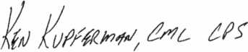

Ken Kupferman, CML, CPS

**2**

Keynotes • November 2007

ABC KEY  
USA

555-1212

USDVA

ILLINOIS

DUPLICATION

PROHIBITED

**Smart Clone**

**For All Cloneable Keys... Including Ford, Infiniti & Toyota**

**Professional Products for Professional Locksmiths**

**Smart Clone Key Blanks**

**Largest Selection of Groovy Keys Anywhere**

**Automotive**

**Transponder**

**Keys**

**Displays and Key Assortments**

intiHiiii

llllIHUH

Uuuuui

**LUUUU1**

**Precision Key Machines and Cutters**

**Master Keying and Fine Duplication**

**View Our Complete Line of Professional Locksmith Hardware at**

**[www.jetkeys.com](http://www.jetkeys.com)**

**Jet**

**Exclusives**

**Uni Bow Neuter Bow Personal Line**

**JET HARDWARE MANUFACTURING CORP**

**800 Hinsdale Street, Brooklyn NY 11207**

|  |  |
| --- | --- |
| SI KVWKSCT !  J KW1 + -1 | | KW1+-~ |
|  |  |

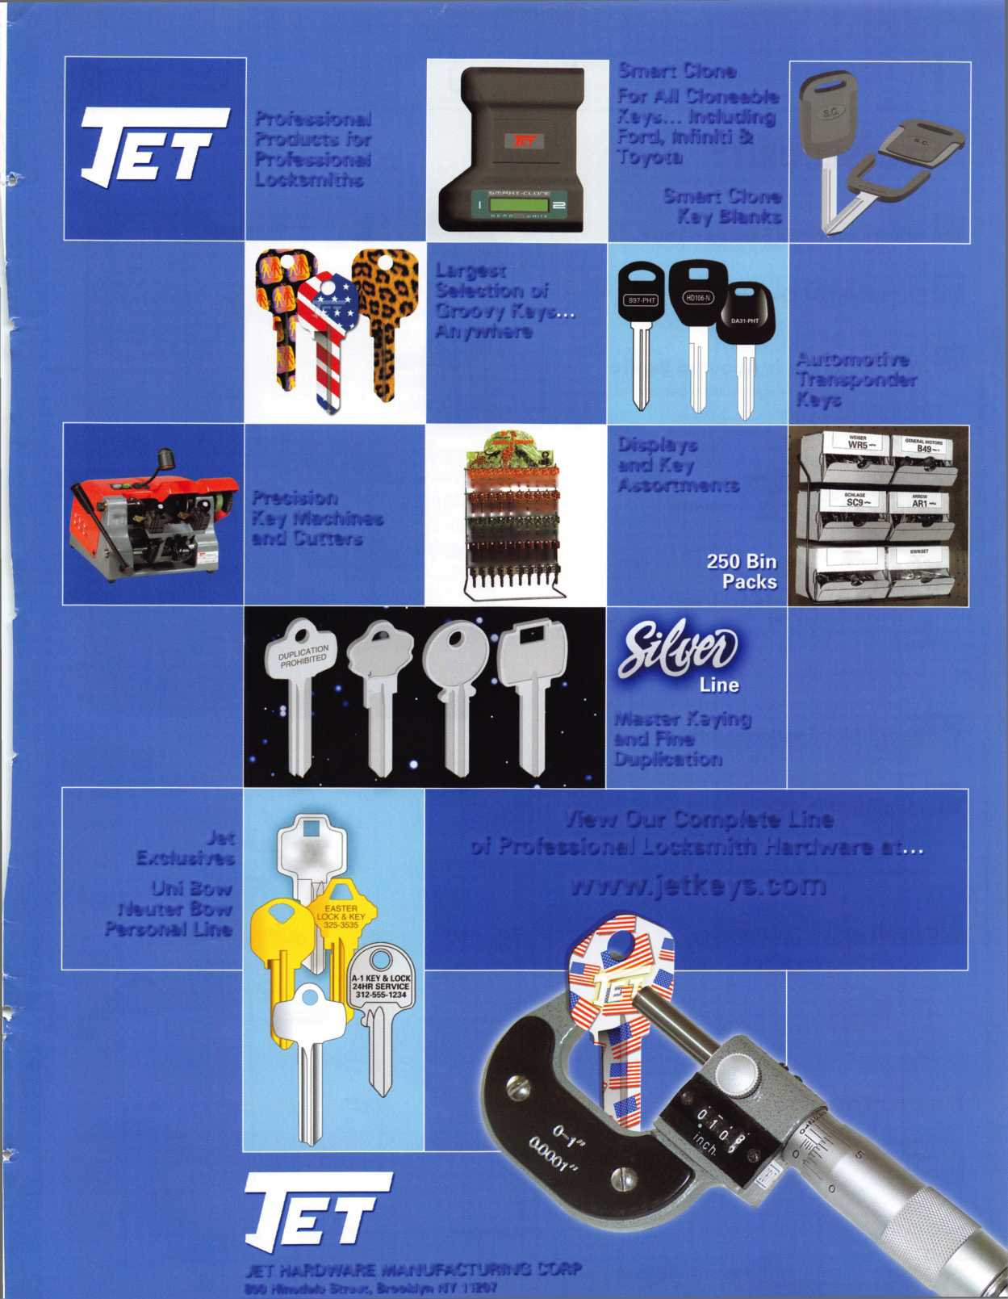

features

AUTO SECURITY

10

What Can NASTF Do For You?

12

Statement of Ownership

**14**

Your Expertise is About to Expire

Its scary to think you might actually become obsolete. Find out what you can do to avoid it.

20

Exhibitor Spotlight: AutoTech Security Systems

"The customer is always rightt!"

22

Door Lock or Safe Lock?

Greg Perry looks at the installation of both an X09 and the CD-X09

by Greg Perry, CML, CPS

**28**

Board Nomination Petition

|  |  |  |
| --- | --- | --- |
| r |  |  |
| AD INDEX |  |  |
| Allstate | Inside Front Cover |  |
| ALOA Education | 1 |  |
| Jet Hardware | 3 |  |
| ALOA 2008 | 7 |  |
| North American Bancard | 15 |  |
| ALOA Training Center | 16 |  |
| H.L. Flake | 17 |  |
| Auto Tech | 19 |  |
| Door King | 25 |  |
| SAFETECH 2008 | 27 |  |
| IR | 29 |  |
| A&B | 40 |  |
| Turn 10 | 40 |  |
| ClearStar | 40 |  |
| PBP | 40 |  |
| North Bennett Street School . | 41 |  |
| Ultra Lift | 43 |  |
| CCL | Back Cover |  |
| L |  |  |

**42**

Membership Mix

Read how ALOA continues to expand its presence  
both domestically and internationally.

by Ellen McEwen, Membership Developement Manager

NEW! Crossword Puzzle

Located on the Inside Back Cover.

**Departments**

|  |  |  |  |  |  |  |  |  |  |
| --- | --- | --- | --- | --- | --- | --- | --- | --- | --- |
| Presidential |  | Executive | 5 | Calendar | 8 | Classified | 34 | Legislative | ...38 |
| Viewpoint | 2 | Applicants .... | 6 | Core | 9 | Associate Members | 36 | Membership. | ...42 |

Visit our NEW website at [www.aloa.org](http://www.aloa.org)

executive

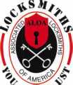

c41\ V*

Volume 53, Issue 10

Additional contact information for the ALOA Board is available on the ALOA website—  
[www.aloa.org](http://www.aloa.org) or by contacting the ALOA office at 3500 Easy Street; Dallas, TX 75247;  
(800)532-2562; FAX (214)819-9736; e-mail [aloa@aloa.org](mailto:aloa@aloa.org).

Editor & Director of Creative Services

Betty Southerland [betty@aloa.org](mailto:betty@aloa.org)

Advertising Sales

Kim Hammond voice: 817-645-6778

Fax: 817-645-7599 e-mail: [adsales@aloa.org](mailto:adsales@aloa.org)

Executive Director

Charles W. Gibson, Jr., CAE [charlie@aloa.org](mailto:charlie@aloa.org)

Associate Executive Director

David Lowell, CML, CMST [david@aloa.org](mailto:david@aloa.org)

Convention & Meetings Manager

Jo Anne Mims [joanne@aloa.org](mailto:joanne@aloa.org)

Operations/Membership Manager

Mary May [mary@aloa.org](mailto:mary@aloa.org)

|  |  |
| --- | --- |
| Director of IT Operations |  |
| Greg K. Jackson | [greg@aloa.org](mailto:greg@aloa.org) |
| Comptroller |  |
| Kathy Romo | [kathy@aloa.org](mailto:kathy@aloa.org) |
| Membership Development Manager | |
| Ellen R. McEwen | [ellen@aloa.org](mailto:ellen@aloa.org) |
| Convention & Meetings Assistant | Karen Lyons |
| Mail Room Coordinator | Kevin Wesley |
| Graphic Designer | ..Margarita Garza |
| Accounting Coordinator | Joyce Nixon |
| Assistant Education Manager | Bob Stafford, CML |
| Legislative Manager Tim McMullen, JD, CAE | |

Contributors

Jerome Andrews, CML  
Paul Chandler, CRL  
Claire Cohen, CML  
Brian Costley, CML, CMST  
Eric Costley, CRL

Ray D'Adamo, CML Billy Edwards, CML Dan Graffeo, CRL,CMST Jim Hancock, CPL Jeff Nunberg, CML, CMST

Randy Simpson, CML, CPP Robert Stafford, CML Dave Thielen, CML Greg Perry, CML,CPS

Tom Seroogy

Charles Stephenson, CPS

Dennis Watanabe, CML, CMST

Mission Statement: The Associated Locksmiths of America, Inc. is dedicated to enhancing the professionalism, education and ethics among  
locksmiths and those in related sectors of the physical security industry. With approximately 8,000 members in the United States, Canada and the free-  
world, ALOA is poised to help members obtain the knowledge, the strength, and the confidence to perform their role in the physical security field with  
pride and dignity. But it is only through active involvement and participation that ALOA can fully achieve its potential—and can help members to achieve  
theirs.

Policies: Keynotes® is the official publication of the Associated Locksmiths of America, Inc. (ALOA). Keynotes® acts as a moderator without approving,  
disapproving, or guaranteeing the validity or accuracy of any data, claim, or opinion appearing under a byline or obtained or quoted from an ac-  
knowledged source. The opinions expressed by the authors do not necessarily reflect the official views of ALOA. Also, appearance of advertisements and  
new products or service information does not constitute an endorsement of products or services featured by the Association. The Association does not ac-  
cept responsibility for the inaccuracy of any data, claim, or opinion appearing in this publication, due to typographical errors on the part of the authors,  
Association staff or its agents.

Editor's Note: This publication is designed to provide accurate and authoritative information in regard to the subject matter covered. It is provided and  
disseminated with the understanding that the publisher is not engaged in rendering legal or other professional services. If legal advice and other expert  
assistance is required, the services of a competent professional should be sought.

Authors' Payment: Payment for eligible submissions to Keynotes will be based on the following criteria: topic, time spent and past contributions. Authors who  
regularly submit to Keynotes® are generally paid a higher rate. The latter is especially true of authors who write to fit specific editorial needs and submit said copy  
by Keynotes® deadlines. As a general guideline: Average payment for a 750 word, business or 'light' technical article would be $200. Payment for a 1500 word  
article involving significantly higher time and research efforts would be $400.

Payment will not be offered for articles submitted by ALOA employees or members of the ALOA Board of Directors (unless material is of a technical na-  
ture), nor for articles submitted by a company that promote that company's products or services. ALOA reserves the right not to pay for articles submitted  
by an individual(s) that promote a particular company's products or services.

Disclaimer: The Associated Locksmiths of America, Inc., (ALOA), reserves the right to refuse any article for any reason. Additionally, ALOA reserves  
the right to edit, amend or modify any article submitted for publication in order to preserve technical accuracy, clarity, fairness or grammatical correct-  
ness. ALOA will make the best efforts to notify the author of any changes. The extent of ALOA's liability for any article or information contained therein  
will be a notice of correction or retraction in the next possible issue.

Keynotes® (ISSN 0277 0792) is published monthly except for the combined June/July issue by The Associated Locksmiths of America, Inc.,  
3500 Easy St., Dallas, TX 75247-6416. Telephone: (214) 819-9733; FAX (214) 819-9736; e-mail [aloa@aloa.org](mailto:aloa@aloa.org). Subscription rates for  
members—$15.00 per year. Periodical class postage paid at Dallas, Texas. POSTMASTER: Send address changes to: Keynotes, 3500 Easy St., Dallas,  
TX 75247-6416. © Copyright 2003, All rights reserved. No part of the contents may be reproduced or reprinted in any form without prior  
written permission of the publisher.

President

Ken Kupferman, CML, CPS  
(813) 232-7600  
[president@aloa.org](mailto:president@aloa.org)

Secretary

John Soderland, CML, CMST  
(414)327-5625  
[secretary@aloa.org](mailto:secretary@aloa.org)

Directors, Northeast

Tom Foxwell  
(410) 206-5772  
ned i rector@aba. org

Robert D. DeWeese, CML, CPS  
(410) 285-0101  
[nedirector@aloa.org](mailto:nedirector@aloa.org)

Directors, Southeast

Tom Gillingham, Jr., CML, CPS  
(615) 300-3777  
sedirector@aloa .org

Steve Myslik, CRL  
(843) 321-9200  
sed i rector@a loa. org

Director, North Central

William Smith, RL  
(920) 893-5282

Guy Spinello, RL  
(815) 394-1000  
[ncdirector@aloa.org](mailto:ncdirector@aloa.org)

Director, South Central

CD Lipscomb, CML, CPS  
(903) 874-3522  
[scdirector@aloa.org](mailto:scdirector@aloa.org)

Directors, Southwest

Greg Parks, CRL  
(858) 271-1155  
swdirector@aioa .org

Gordon Racine, CML  
(719) 384-4707  
swdirector@aloa .org

Director, Northwest

Keith E. Whiting, CML, CFL  
(360) 601-5656  
nwd i rector@aloa. org

Director, International

Hans Mejlshede, CML  
(453) 539-3939  
eurdirector@aloa .org

Director, Associate

Dan Floeck  
(800) 231-4105  
asd i rector@aloa. org

Trustees

[trustees@aloa.org](mailto:trustees@aloa.org)

Robert E. Mock  
(856) 863-0710

Randy Simpson, CML, CPP  
(281) 240-5959

William Young, CML, CPS  
(610) 647-5042

Past Presidents

2005-2007 Robert E. Mock  
2003-2005 William Young, CML, CPS  
2001-2003 Randy Simpson, CML  
1999-2001 John Greenan, CML, CPS  
1997-1999 Dallas C. Brooks  
1995-1997 David Lowell, CML, CMST  
1993-1995 Breck Camp, CML  
1991-1993 Henry Printz, CML  
1989-1991 Evelyn Wersonick, CML, CPS  
1987-1989 Leonard Passarello, CPL  
1985-1987 Joe Jackman, CML  
1983-1985 Stanley Haney, CPL  
1981-1983 Louis LaGreco, CPL  
1979-1981 John Kerr, RL  
1977-1979 Clifford Cox, CML  
1974-1977 Charles Hetherington  
1972-1974 Gene Laughridge  
1970-1972 William Dutcher, RL  
1968-1970 Constant Maffey, RL  
1966-1968 Harold Edelstein, RL  
1964-1966 William Meacham  
1962-1964 Robert Rackliffe, CPL  
1960-1962 Edwin Toepfer, RL  
1956-1960 Ernest Johannesen



Keynotes • November 2007

Morehead

Colorado Springs

Scott P. Graves

Sponsor: Raymond J. D'Ada mo

CML

Fort Collins

Rod Rogers

Sponsor: Raymond J. D'Ada mo

CML

Bradenton

Jeff R. Burbeck

Miami

Keith McCray

Orlando

Bernard S. Edwards II

Atlanta

Hezekiah Montia

Loganville

Craig Bowie

Rincon

Christopher Bragg

Sponsor: Jack A. Walder

Adrian Feria

Sponsor: Michael K. Yarberry CML, CPS

Leominster

Stephan Chromiak

Sponsor: Charles E. Batcke CPL,

CPS

Spicer

Steve Hogenson

Sponsor: A Lowell Torkelson CRL

Las Vegas

Ben Payne

Sponsor: Robert J. Reynolds CRL, CPS

Brooklyn

Roger Schillizzi

Memphis

U Lynes

ummm

Dallas

William L. Douglas II

Sponsor: Clifford D. Lipscomb CML, CPS

iexico

Italnepantla

Felipe Lara Lopez

Sponsor: Octavio R. Garcia Abrego

Mexico City

Jorge A. Jacinto

Sponsor: Octavio R. Garcia Abrego

Little Chute

Miguel A. Campos Ramos

Sponsor: Octavio R. Garcia Abrego

N Charleston

John J. Laukaitis CPL

These applicants are scheduled for clearance as members of ALOA. The names are published for member review and comment within 30 days of this Keynotes issue date, respectively, to ensure appli­cants meet standards of ALOAs Code of Ethics. Protests, if any, should be addressed to the Membership Department and must be signed. Active Membership applicants (a) have worked in the industry two or more years. Allied Membership (AL) applicants are not locksmiths, but work in a security-related field. Apprentice Membership (AP) applicants have worked in the industry less than two years.

Keynotes • November 2007

JUNE 15-22, 2008 • DALLAS, TEXAS

CLASSES

Strap on your cowboy

boots! In 2008, we are cele­brating the 52nd annual ALOA Convention and Expo in Dal­las, Texas. ALOA 2008 of­fers plenty of exciting classes and seminars that will educate and expose you to some of the best security-related tech­nology the industry has to offer.

PLUS...MORE FUN!!

* Kick-Off Party
* ALOA Golf Tournament
* Tour
* Banquet
* Networking

Having built an international reputation among locksmiths as a powerful resource to ex­plore industry alliances, ALOA 2008 is the ideal place to learn, network or showcase your business on the show floor.

**For more information about Dallas, Texas please visit: www. dallascvb. com/visitors**

|  |  |
| --- | --- |
| s | tra |
| d( | 3SCri[ |
| PI | ease |

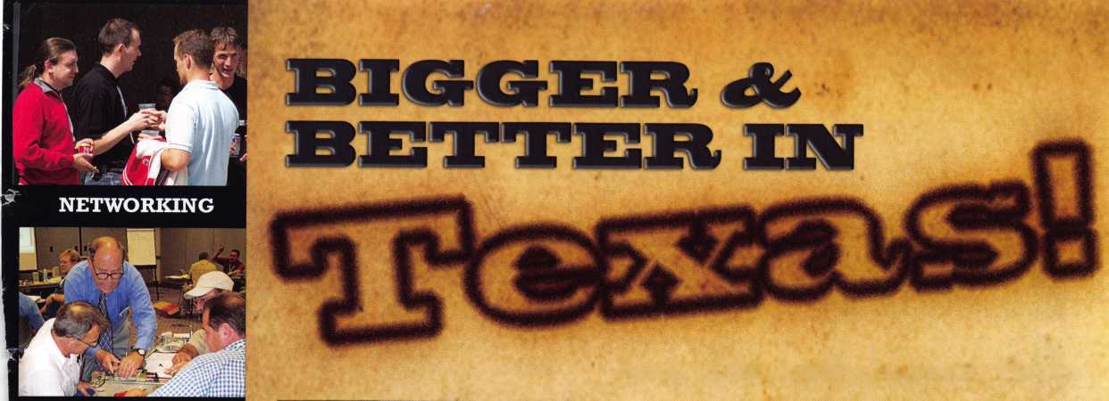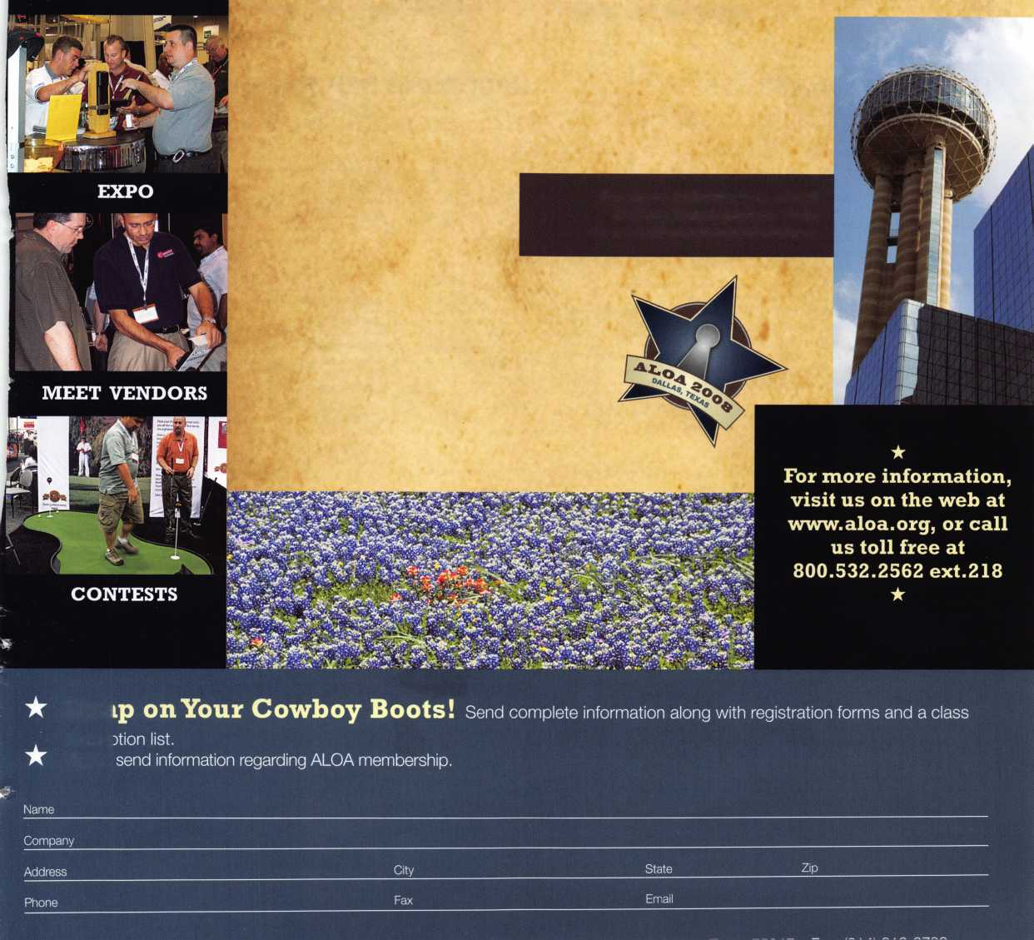

upcoming events

11/7-11

Clark Security Products Security Expo Baltimore, MD Marriott BWI [www.clarksecurity.com](http://www.clarksecurity.com)

2/6-9 TLA Convention  
Austin, TX

Radisson Hotel Austin North 6000 Middle Fiskville Road

Resv: (888) 201-1718 Tel: (512) 451 -5757 Fax: (512) 467-7644

|  |  |  |
| --- | --- | --- |
| 3/6-9 2008 Trade Show & | Contact: Ronald Weston | 3/31-4/5 SAFETECH 2008 |
| Security Conference | 734-293-0082, | SAVTA Convention |
| IDN-Hardware Sales, Inc. | or Bonnie Weston | & Tradeshow |
| Novi, Michigan | 734-293-0061 | San Diego, California |
| Sheraton Detroit Novi, 21111 Haggerty Road |  | savta.org • 214-819-9771 |

UPCOMING ACE CLASSES

Connecticut • Nutmeg Locksmith Trade Association  
Defense Against Methods of Entry  
Safe Lock Servicing for Locksmiths  
Bill Brooks, RL • 203-269-7643  
Baltimore, MD • Clark Security Products  
Safe Lock Servicing, Transponder Servicing  
Joan Emrick • 858-974-6737  
[www.clarksecurity.com/Events.aspx?event«Easternre](http://www.clarksecurity.com/Events.aspx?event%C2%ABEasternre)  
Ft. Wayne, IN • Northern Indiana Chapter of ALOA  
PRP Exam, Domestic Auto w/L-03 PRP, Foreign Auto w/L-04 PRP  
Jeremy Rodocker, CML, CPS • 260-459-1500  
[rodockers@hotmail.com](mailto:rodockers@hotmail.com)

Dallas, TX • ALOA Training Center • [www.aloa.org](http://www.aloa.org)  
Six-Day Basic Locksmithing Course

ALOA Education • 800-532-2562x101 • [education@aloa.org](mailto:education@aloa.org)  
Dallas, TX • ALOA Training Center • [www.aloa.org](http://www.aloa.org)  
Three-Day Master Keying Symposium  
ALOA Education • 800-532-2562x101 • [education@aloa.org](mailto:education@aloa.org)  
Dallas, TX • ALOA Training Center • [www.aloa.org](http://www.aloa.org)  
Keyless Mechanical Lock Servicing w/L-20 PRP  
Life Safety Codes w/L-07 PRP

ALOA Education • 800-532-2562x101 • [education@aloa.org](mailto:education@aloa.org)  
Casper, Wyoming • Wyoming Locksmiths Assn.

Automotive Locksmithing Update  
Jim O'Grady • 307-234-5932

Lincoln, Nebraska • Nebraska Chapt. of ALOA • [safeman@cox.net](mailto:safeman@cox.net)  
Servicing Aluminum Storefront Doors  
Elmer Howard • 402-676-8973  
Austin, Texas • Texas Locksmiths Association Convention  
Fundamental Locksmithing (3 days)

Basic Electricity & Electronics w/ L-l 3 PRP  
Installing & Servicing Access Control w/L-40 PRP  
John Arnold, CML • 972-245-9583 • [key.express@usa.net](mailto:key.express@usa.net)  
Eagan, Minnesota • Minnesota Chapter of ALOA  
Multipoint Hardware & Profile Cylinder Servicing  
Professional Picking Techniques, Door Closers  
Professional Impressioning Techniques, PRP Exam  
Dana Lee, CML, CPS • 612-968-3257 • [dana337@mac.com](mailto:dana337@mac.com)  
Dallas, TX • ALOA Training Center • [www.aloa.org](http://www.aloa.org)  
Security Hardware Installers Course (3 days)

ALOA Education • 800-532-2562x101 • [education@aloa.org](mailto:education@aloa.org)  
Dallas, TX • ALOA Training Center • [www.aloa.org](http://www.aloa.org)  
Six-Day Basic Locksmithing Course

ALOA Education • 800-532-2562x101 • [education@aloa.org](mailto:education@aloa.org)  
San Diego, California • SAFETECH 2008 • [www.savta.org](http://www.savta.org)  
Safe & Vault Classes • SAVTA Education • 214-819-9771

UPCOMING PRP Sittings

11 /4/07 Sunday 9:00am • Syracuse, NY • Ron Smith, CPL, CPS

Central New York Locksmiths Assn.* [advsl@imcnet.net](mailto:advsl@imcnet.net) 315-782-0912 • Rescheduled from Oct. 7

11/11/07 Sunday 8:00am • Baltimore, MD • Joan Emrick

Clark Security Products • [joan.emrick@clarksecurity.com](mailto:joan.emrick@clarksecurity.com) 858-974-6737

11/16/07 Friday 3:30pm • Fort Wayne, IN • Jeremy Rodocker, CML, CPS

Northern Indiana Chapter of ALOA • [rodockers@hotmail.com](mailto:rodockers@hotmail.com) 260-459-1500

12/1/07 Saturday 8:00am • Hoover, AL • Benny Hopper

Alabama Locksmiths Assn. • [hoover6070@aol.com](mailto:hoover6070@aol.com) 205-823-2843 • JUST ADDED

12/8/07 Saturday 1:00pm • Dallas, TX • ALOA Certification

ALOA Training Center • [education@aloa.org](mailto:education@aloa.org) 800-532-2562x101

12/9/07 Sunday 1:00pm • Muskego, Wl • John Soderland, CML, CMST

[prolock@aol.com](mailto:prolock@aol.com) • 414-327-5625

1/12/08 Saturday 8:00am • Dallas, TX • ALOA Certification

ALOA Training Center • [education@aloa.org](mailto:education@aloa.org) 800-532-2562x101 • JUST ADDED

2/9/08 Saturday 8:00am • Austin, TX • ALOA Certification

Texas Locksmiths Association • [education@aloa.org](mailto:education@aloa.org) 800-532-2562x101 • JUST ADDED

2/10/08 Sunday 8:00am • Eagan, MN • Dana Lee, CML, CPS

Minnesota Chapter of ALOA • [dana337@mac.com](mailto:dana337@mac.com) 612-968-3257 • JUST ADDED

2/23/08 Saturday 8:00am • Dallas, TX • ALOA Certification

ALOA Training Center • [education@aloa.org](mailto:education@aloa.org) 800-532-2562x101 • JUST ADDED

3/15/08 Saturday 8:00am • Dallas, TX • ALOA Certification

ALOA Training Center • [education@aloa.org](mailto:education@aloa.org) 800-532-2562x101 • JUST ADDED

Contact the ALOA Education De­partment for a list of classes and training offered in-house.

November 3 & 4, 2007

**CANCELLED**

November 7, 2007

November 16-18, 2007

December 3-8, 2007

December 6-8, 2007

January 11-12, 2008

January 12, 2008 January 19, 2008 February 6-8, 2008

February 8-10, 2008

February 21-23, 2008 March 10-15, 2008

March 31-April 5, 2008

w #

core

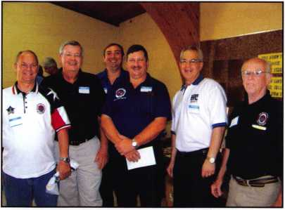

ALOA Board  
Secretary John  
Soderland  
(left), and  
North Central  
Director Bill  
Smith (right) at-  
tended the an-  
nual IDN H.  
Hoffman Brat-

fest and trade show in Milwaukee Wl in August. John and Bill are  
pictured with representatives from Alarm lock, Multi-lock, the Institu-  
tional Locksmiths Association, and HPC, Inc.

Bratfest

A good time was had by all, and nobody left the event hungry.

New Chapter Awards Big Prize

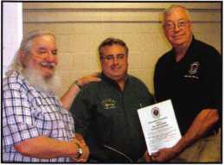

At the first meeting to resurrect  
ALOA Chapter 5, which is now  
to be called "Nation's Capitol  
Chapter 5 of ALOA" there were  
30 people in attendance to ellect  
new board offficers. The meeting  
was held on Sept.27,2007 at the  
Kensington Town Hall in Kensing-  
ton, MD. ALOA donated a door  
prize of a Convention package  
for one person. The winner is

Gary Baldino of Colonial Supply. Lester Brodosky and Tom Foxwell  
ALOA N.E.Director present the award too Gary Baldino. Contact  
Lester Brodsky for future meeting dates and times at 301-949-7582.

Condolences

Alarm Lock's PG21MS Series Door Alarms

Farley A. Sparks, CRL passed away on May 30, 2007 in Florida.  
James Bellamy, ALOA Member died in December of 2006.

Security Door Plates

A creative concept designed  
with security and safety in  
mind...

The invention of the Security  
Door Plates offers a new concept  
for a set of plates, one a striker  
plate and the other to be fitted to  
the door, designed to be used  
with any traditional door lock.

The specially designed plates would include two tapered exten-  
sions, running the length on either side of the mounted plate, seal-  
ing the area where the door and door frame meet. This design  
would effectively block access to the actual lock, preventing jimmy-  
ing of the lock and illegal entry into the structure.

This product is designed to provide quick exit from the home in case of fire or other emergency, without the need to fumble with keys to unlock a deadbolt or disengage other complicated systems.

The innovative Security Door Plates was ingeniously invented by Robert Marshall of Houston, Texas and can be found at [www.ad- ventproduct.net/17808/default.htm](http://www.ad-ventproduct.net/17808/default.htm).

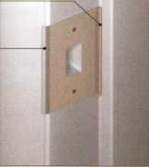

Alarm Lock's multi-purpose PG21MS Series offers advanced narrow

stile microprocessor-controlled door alarms for surface  
mounting on a door or doorframe. Typical applications  
include emergency fire escape doors, nursing home  
stairwell doors, rear restaurant and theater doors. The  
series work in two arming modes. Always Armed  
Mode causes the key to stay in place unless you turn  
the system back to arm from the disarm mode, keeping  
the unit armed always. Standard Arming Mode allows  
the user to disarm the system and remove the key. Turn-

ing the key clockwise will once more arm the system, with the op-  
tion of taking your key out.

Features include a continuous alarm or 2-minute shutdown with auto reset and exit/entry delay status indicator LED light that becomes red when the system is armed. For entry, PG21MS has delay time options to include 15 seconds, 1 minute, 15 seconds and 3 minutes 15 seconds. Unauthorized use of the door causes the alarm to sound and the LED indicator to activate.

Multi-door monitoring is permitted with our built-in external reed switches. These versatile door alarms use a standard mortise cylin­der and an optional RIM cylinder may be used for exterior key con­trol. They come with a supervised tamper switch and Max-Flex Terminals, allowing for continuous power with the addition of an ex­ternal power supply. The sleek design works on standard size and narrow stile doors and comes in metallic silver or duronodic finish.

If you wish to include a highly visible amber strobe, you can do so with PG21MSS/PG21MBS. These units will flash when the unit goes into alarm mode.

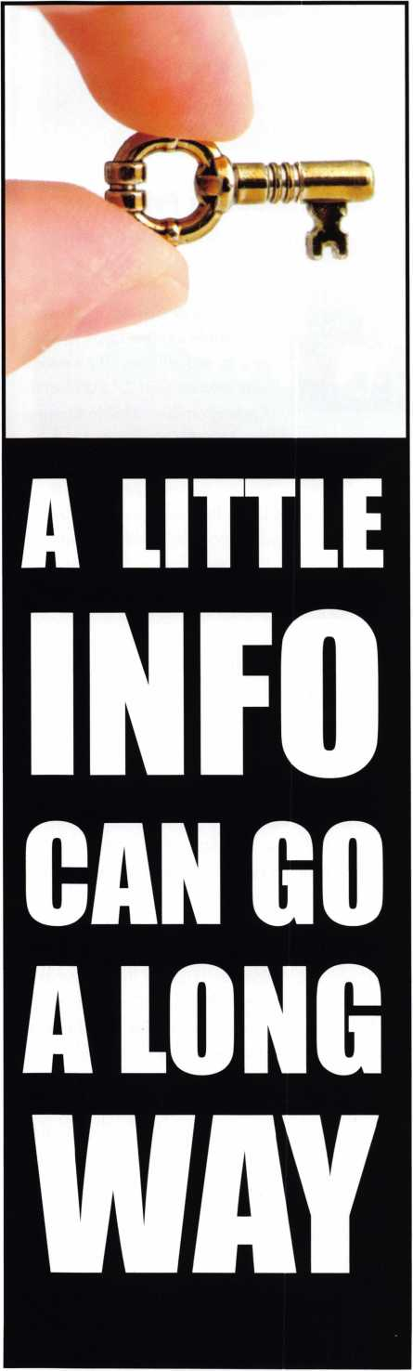

Portions of this article were reprinted with permission from Canadian Technician.

What Can NASTF Do For YOU?

The National Automotive Service Task Force site is one of the fastest and easiest ways for automotive locksmiths to access the OEM tools, training, flash downloads, and service information they need to service cars.

This information is paramount critical today when service techni­cians across the country are fighting for the "right to repair” all ve­hicles, and when even the simplest of jobs requires access to current and accurate code information.

Everyday, there are technologies being introduced on new cars which can not only be a hassle for the locksmith but can affect your bottom line due to lost work and delays.

Many consumers are comfortable bringing their cars - even the newest ones - to the independent sector of the aftermarket. So it follows that these independent shops need access to the most up-to- date service information available. Keeping up with the latest tools, equipment, and training is essential.

Many locksmiths have developed "work around” solutions, using back-door connections to get the information or tools they require. But working back-door deals and relying on favors from dealerships is not only tricky and time-consuming, it's beneath the dignity of many respected business owners and technicians who have estab­lished themselves as legitimate professionals.

And that's where NASTF comes in.

The NASTF site is an alternative to asking a local dealership for a "favor.” NASTF provides an easy way to get this information quickly and affordably, by simply logging on and following some pretty straightforward navigation.

It's one-stop-shopping for your lock shop.

It's not a perfect process, but NASTF's web site can be a real help if there's something you need to know or something you need to have in order to service a vehicle. You go right to the source and get your information first hand like a respected professional should.

Here are some of the basics of the NASTF web site to get you started, and details on how to make things better for everyone in­volved.

The web site itself is easy to navigate since the information is organ­ized into well-designed sections, listed along the edge of the screen. Even novice computer users will have little trouble navigating the site.

There aren't tons of graphics which means the web site loads quickly even on older machines. There's an information section (or matrix) for service information, another for training (manufacturer training courses), another for tools, and even one for collision work. Pro­gramming and calibration downloads are also available, along with information about how to program the device in question.

Each matrix has links to a manufacturer's information, and it in­cludes details on how to order or access what you need. There may be a fee. Simply enter a credit card number and the download starts

immediately. Some information is still not available to those who live outside of the United States.

At the site, you can buy a temporary subscription to a par­ticular manufacturer's service information web site - usu­ally at a very reasonable price (certainly less than the cost of lost time spent phoning around asking for favors).

The matrix also lets you know if the manufacturer isn't sharing their information (some don't).

Some time spent surfing should give you a good idea of the scope of the site, and may even bring you face-to-face with some of its limitations.

The most notable limitation is the problem of manufactur­ers not providing information on their products. True, the web site's information is continuously updated but some­times the information is just simply not available—even though the manufacturer has it listed. Or there may not be any information listed for a certain area at all.

That's where your input can help.

The single most important thing locskmiths can do to help with this problem is to report problems using the links available on the web site using the "Contact Us" link. Tak­ing the time to report problems or request information is worthwhile because registered complaints are what make the web site an even better resource for everyone involved. (And we all know that locksmiths are usually pretty good about complaining when things are unfair.)

Foreign users should particularly lodge complaints when their credit cards fail to work and information they need is denied them. The "Right To Repair" campaign is under­way in the United States, but sometimes our voices need to be heard when we are locked out of repair information.

The complaints aren't just ignored or filed away. They are routinely investigated and taken up at the next meeting of the "Congress of Automotive Repair and Service held each year in Las Vegas. If there are few complaints, everyone will assume things are working quite well, even if the reality may be something else entirely. So make sure your con­cerns are registeredy and heard! Consider it as a way to “give back” to your industry.

Better yet, plan a trip to Las Vegas during what is commonly known as "Automotive Industry Week" (the Automotive Af­termarket Parts Expo and the Specialty Equipment Manu­facturers Association show are held simultaneously and certainly worth attending) take an afternoon out to attend the annual NASTF meeting. It is open to all, and all the major players are in the room with you. If you've got kudos or criticisms, the right person will hear them.

Whatever your thoughts on the "Right to Repair" issue facing the industry, the NASTF web site gives technicians and shop owners the ability to make some of their own

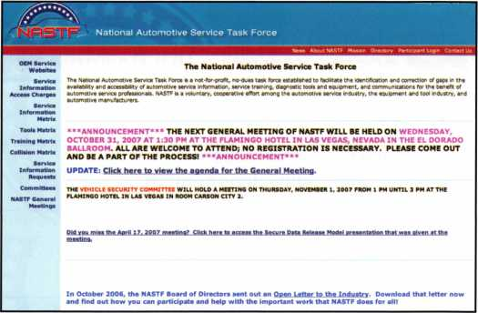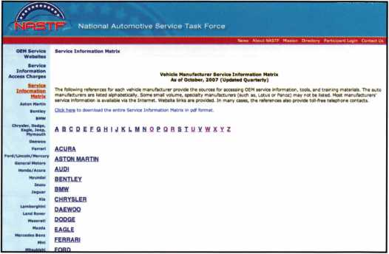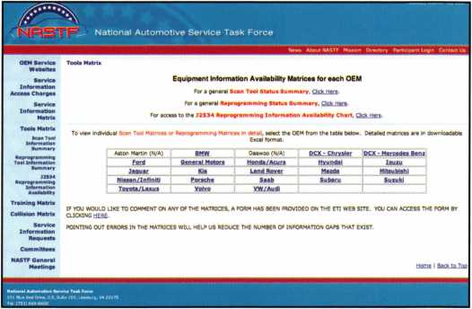

choices regarding three of the biggest obstacles in the in­dustry: access to tools, access to training, and access to service information. True, some shops and technicians get by without any of these. But rather than relying on favors or "back alley" methods to access information or tools, NASTF strives to make the three things easily accessible and affordable - even free in some cases.

The NASTF web site is important to independent shops and technicians because it gives them control over their fu­tures and gives them options for getting crucial service in­formation for even the simple jobs they encounter every single day.

***UNITED STATES*** POSTAL SERVICE®

Statement of Ownership, Management, and Circulation  
(All Periodicals Publications Except **Requester Publications)**

|  |  |  |  |  |  |  |  |  |  |  |
| --- | --- | --- | --- | --- | --- | --- | --- | --- | --- | --- |
| 1. Publication Title | 2. Publication Number | | | | |  |  |  |  | 3. Filing Date |
| Keynotes | 0 | 2 | 7 | 7 | - | 0 | 7 | 9 | 2 | 10/11/2007 |
| 4. Issue Frequency  Monthly (bimonthly July/August) | 5. Number of Issues Published Annually  ii | | | | | | | | | 6. Annual Subscription Price  Member Benefit |
| 7. Complete Mailing Address of Known Office of Publication (Not printer) (Street, city, county, state, and ZIP*4®} | | | | | | | |  |  | Contact Person |

3500 Easy Street Dallas, Texas 75247

**Betty Southerland**

**Telephone** (Include area code)

214-819-9733 x204

8. Complete Mailing Address of Headquarters or General Business Office of Publisher **(Not printer)**

Same

**9. Full Names and Complete Mailing Addresses of Publisher, Editor, and Managing Editor (Do not leave blank)** Publisher **(Name and complete mailing address)**

Associated Locksmiths of America 3500 Easy Street • Dallas, Texas 75247

**Editor** (Name and complete mailing address)

Betty Southerland

3500 Easy Street • Dallas, Texas 75247

**Managing Editor** (Name and complete mailing address)

Same

**10. Owner** (Do not leave blank. If the publication is owned by a corporation, give the name and address of the corporation immediately followed by the names and addresses of all stockholders owning or holding 1 percent or more of the total amount of stock. If not owned by **a** corporation, give the names and addresses of the individual owners. If owned by a partnership or other unincorporated firm, give its name and address as well as those of each individual owner. If the publication is published by a nonprofit organization, give its name and address.)

|  |  |
| --- | --- |
| Full Name | Complete Mailing Address |
| Associated Locksmiths of America | 3500 Easy Street • Dallas, Texas 75247 |
|  |  |
|  |  |
|  |  |
|  |  |

11. Known Bondholders, Mortgagees, and Other Security Holders Owning or  
Holding 1 Percent or More of Total Amount of Bonds, Mortgages, or

Other Securities. If none, check box - -► □ None

|  |  |
| --- | --- |
| Full Name | Complete Mailing Address |
|  |  |
|  |  |
|  |  |
|  |  |
|  |  |

**12. Tax Status** (For completion by nonprofit organizations authorized to mail at nonprofit rates) (Check one)

The purpose, function, and nonprofit status of this organization and the exempt status for federal income tax purposes: □ Has Not Changed During Preceding 12 Months

**O Has Changed During Preceding 12 Months** (Publisher must submit explanation of change with this statement)

PS Form **3526,** September 2007 **(Page 1 of 3 (Instructions Page 3))** PSN 7530-01-000-9931 PRIVACY NOTICE: See our privacy policy on **[www.usps.com](http://www.usps.com)**

|  |  |  |  |  |
| --- | --- | --- | --- | --- |
| 13. Publication Title  Keynotes | | | 14. Issue Date for Circulation Data Below  September 2007 | |
| 15. Extent and Nature of Circulation | | | Average No. Copies Each issue During Preceding 12 Months | No. Copies of Single Issue Published Nearest to  Filing Date |
| a. Total Number of Copies (Net press run) | | | 7000 | 7000 |
|  | (i) | Mailed Outside-County Paid Subscriptions Stated on  PS Form 3541 (Include paid distribution above nomi­nal rate, advertiser's proof copies, and exchange copies) | 6212 | 6139 |
| b. Paid Circulation (By Mail and | (2) | Mailed In-County Paid Subscriptions Stated on PS  Form 3541 (include paid distribution above nominal rate, advertiser's proof copies, and exchange copies) | 72 | 73 |
| Outside the Mail) | (3) | Paid Distribution Outside the Mails Including Sales  Through Dealers and Carriers, Street Vendors, Counter  Sales, and Other Paid Distribution Outside USPS® | 0 | 0 |
|  | (4) | Paid Distribution by Other Classes of Mail Through the USPS (e.g. First-Class Mail®) | 0 | 0 |
| c. Total Paid Distribution (Sum of 15b (1), (2), (3), and (4)) | | | 6284 | 6212 |
|  | (D | Free or Nominal Rate Outside-County  Copies included on PS Form 3541 | 0 | 0 |
| d. Free or Nominal  Rate  Distribution | (2) | Free or Nominal Rate In-County Copies Included on PS Form 3541 | 0 | 0 |
| (By Mail and  Outside the Mail) | (3) | Free or Nominal Rate Copies Mailed at Other  Classes Through the USPS (e.g. First-Class Mail) | 0 | 0 |
|  | (4) | Free or Nominal Rate Distribution Outside the Mail (Carriers or other means) | 300 | 400 |
| e. Total Free or Nominal Rate Distribution (Sum of 15d (1), (2), (3) and (4)) | | | 300 | 400 |
| f. Total Distribution (Sum of 15c and 15e) ^ | | | 6584 | 6212 |
| 9- Copies not Distributed (See Instructions to Publishers #4 (page #3)) ^ | | | 416 | 388 |
| h. Total (Sum of 15f and g) ^ | | | 6884 | 7000 |
| j Percent Paid ^  (15c divided by 15f times 100) W | | | 95.44% | 93.95% |

16. Publication of Statement of Ownership

If the publication is a general publication, publication of this statement is required. Will be printed

in the **November 2007** __ issue of this publication.

Q Publication not required.

17. Signature and Title of Editor, Publisher, Business Manager, or Owner

Date

October 24, 2007

I certify that all information furnished on this form is true and complete. I understand that anyone who furnishes false or misleading information on this form or who omits material or information requested on the form may be subject to criminal sanctions (including fines and imprisonment) and/or civil sanctions (including civil penalties).

PS Form **3526,** September 2007 **(Page 2 of 3)**

Your Expertise is About to Expire

By Ross Shafer



The headline got your attention didn’t it?

It’s scary to think you might actually become obsolete. What’s really frightening is to already be obsolete and not even know it.

In my job I get the opportunity to attend 80+ conferences and conventions each year. I have a front-row seat to a myriad of best practices - and then do my best to cross- pollinate them at the next conference.

You see, it doesn’t matter that you’ve been an expert in your field for 20 years. Or that you are a leading expert in your field, today. What are you doing to make sure you’re an expert tomorrow? In ten years? You already know that technology changes weekly. You know that today’s work­force consists of four wildly different generations. And, you just heard your competition recently went “global” - or has started franchising. Bold growth begs to ask bold questions.. .like, “Am I still relevant?”

Are you relevant to your customers, your clients, your patients, and your employees? If you aren’t important to your core (and vital) constituents, you are destined to experience a withering market share and the loss of your most talented staff members.

So what can you do about keeping your edge? How can you continue to grow when the trends seem to be outpac­ing you?

Attend Another Industry’s Convention.

Yes, I’m actually asking you to visit a big general meeting that has nothing to do with locksmithing at a hotel near you. Find out what big convention is in town. Dress well. Show up. 95% of the time you’ll be able to sit down and soak up some information that will likely revolutionize your business.

Example: I went to a grocery convention and found out that 42% of grocery shop­pers still don’t know what they want for dinner at 4:00pm. I passed on that valuable tid-bit to a chain of successful seafood restau­rants. They immediately start­ed running their radio ads at 3:00pm. Planting another meal option in the minds of the listeners (when they are starting to think about dinner) has caused their restaurant business to climb.

Best Practices Are a Moving Target.

What works today might not work tomorrow.

I heard Jack Welch tell a group of tech executives that when he ran General Electric he would actually penalize a



Keynotes • November 2007

manager for not being forthcoming about a better way he/she was doing things. That policy became an inside joke at G.E. A manager would call Jacks office and say, “Hey, I think we re onto something really cool in Des Moines. Please tell Jack so I don’t get caught with it.”

Companies like 3-M are never satisfied with exceeding sales goals on today’s great products. They take enormous pride in the fact that 30% of their products didn’t even exist four years ago. They innovate to remain relevant.

I was at a Kodak camera meeting in the late 90’s where a top sales executive stood up and told the group, “Don’t be freaked out by digital photogra­phy. It’s a fad.” Endorsing that kind of irrele­vance has diminished their stock value, their

What works today might not work tomorrow.

NorthAmerican

BANCARD

JliiL Gaped EsHmercj

A wholly owned subsidiary of North Ar

***The Best Credit Card Equipment***

***Is Your Bank  
Not Giving You  
A Loan?***

Keynotes • November 2007



employee recruiting, and their market share. I wonder if the folks at Polaroid had similar denial toward the digital revolu­tion.

Stop Losing Sleep Over Technology.

If you have email, a web site, a reliable server, and the ability to sell products and services online, you’re doing great. You’re better off worrying about the human communication skills of your work force. With the rampant proliferation of cell phones, voicemail, email, and text messaging, more and more of your customers and clients are craving human contact. They want to talk to human beings. They want a trusted relationship with you so they can stop “dating” your compe­

tition. Honestly, they could care less what generation of routers and switchers you’re running. They want you to listen to what they need - then consult them on their choices.

We teach Customer Empathy™ classes instead of customer “service” because today’s customers want you to understand their point of view before, during, and after the transaction. They want you to know they often feel helpless, out of con­trol, and anxious about the purchase; especially if it’s a high- ticket item. You may be a person who sells homes, comput­ers, or BMW’s all day long. But your customer may only buy an item that huge 2-4 times in their lifetime. Creating a trusted emotional connection between you and your cus­tomer is the only recipe for long-term customer loyalty.

.,k* ALOA TRAINING CENTER

ivSyJ Three Day Master Keying Symposium

' 4 x v*

|  |  |
| --- | --- |
| Course Description |  |
| This flexible educational program gives students access to master keying instruction at their own pace. Day one is open to students who have completed the basic locksmithing class or have equivalent expe­rience. Subsequent days are open to students who a have completed the previous class. Students are welcome to take all three days in a single session, or break the experience up as needed. Students with master keying experience are encouraged to bring keying problems to class. Students will also need a | |
| calculator, 2 pens, a notebook. |  |
| Students Receive: | Course Date: |
| • Master Keying Class Manual | December 6, 7, and/or 8 (Class Hours are 8am - 5pm each day) |
| • Fundamentals of Master Keying  Book by Jerome Andrews, CML |
| Class Location: ALOA Training Center (see below) |
| • An ACE Certificate attesting 8 credit hours of CE instruction for each day. |
| Price: $150.00 for one day, $275.00 for two days, $375.00 for three days. |
| • One point toward ALOA PRP recertification for each day of class attendance. |
|  |

For additional information please contact 800-532-2562 x104, E-mail: [education@aloa.org](mailto:education@aloa.org)

**6**

Keynotes • November 2007

*[www.hlflake.com](http://www.hlflake.com)*

**H.L. Flake Co.**

Over 95 years of quality service

a small order away!

than 3 days away!

FREE GROUND FREIGHT WITH:

L- I $ 95 .** order

**1 I** $115.” order I I $135-order

FREE FREIGHT  
(excludes key machines, safes, & bulk key orders)  
(within contiguous 48 states)

BUSINESS DAYS

3 DAYS AWAY

2 DAYS AWAY

*wmmm*

OVER WEEKENDS, ADD 2 DAYS

Please know that if you have a preference on your delivery carrier, it may extend the delivery time of your package. The delivery time will not exceed 3 business days.

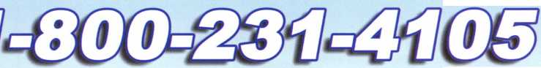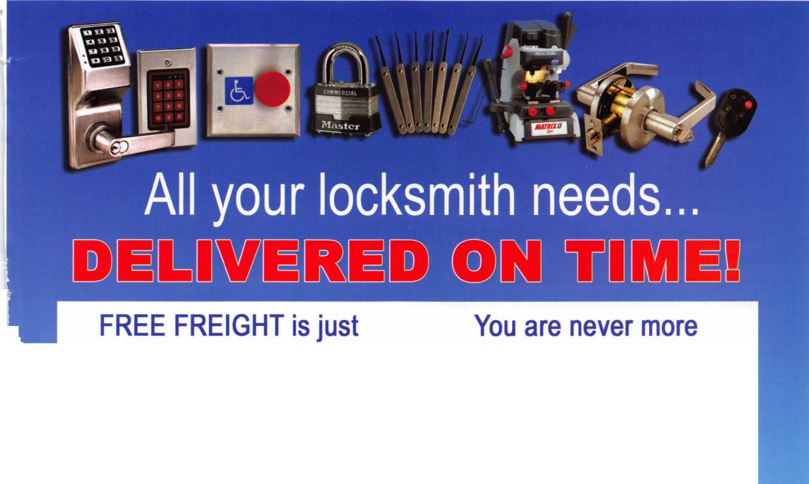

Listen to Our Culture.

Don’t just subscribe to your industry magazines.

Every month, go to your local newsstand (or go online) and read a variety of publications you normally wouldn’t read. Pick magazines about science, medicine, sports,

Ross Shafer is a popular speaker and expert on best practices and business growth. He is the author of “Remaining Relevant” How Great People and Organizations Keep Growing (due Jan. *2008*) as well as “Nobody Moved Your Cheese” and “The Customer Shouts Back. ” For more informa­tion about Ross, visit [www.RossShafer.com](http://www.RossShafer.com)

money, guitars, and women’s issues. Get a sense of what our culture is talking about. How are they spending their time? How are they spending their money? Listen to people talk at the supermarket, the drug store, the fast food restau­rant, the hardware store...wherever.

You’re listening for “buzz.” Buzz is the new stuff everybody is talking about.

You want to be buzz.

Young people know about buzz. They are often early adopters of technology, games, phone services, and any­thing fun and interesting. Their shorter attention spans demand it. Have a meeting with the Millennial in your workforce. Ask them what web sites they surf. Ask them where they spend their weekends and off time. Ask them to help you set up a Wikipedia page or upload homemade company videos to YouTube. Young people are relevant by design and peer pressure. They embrace change because change means “better.” Remember, they’re anxious to download software upgrades.

If you take an active interest in paying attention to life and humanity, obsolescence will never be your problem. Plus, you’ll have plenty of time to focus on more important crises.. .like your hairline?



Keynotes • November 2007

■SHI I % # I

Thank You!

% AAA $m T>edleu,

For Making The Program

Such A Success!

The Friendly Staff of,

Auto Tech Security Systems

**STOP**

Util

« »m •••

L**f

¥** *.*

**,** SENDING THEr TO THE DEALER

It's SIMPLE to sell renoteuet us show you low!

http;//www.aiftotech$. com/dealer/info, htm

2007 Deaier Kit Only $799.95

*J

imi

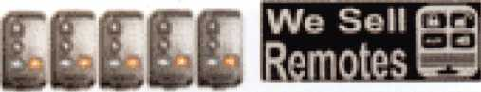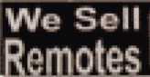

**Now Available in Spanish version**

**W# know iwvkMmi... «k>** you **eton'1 Kwo t-o'**

***Jutomech***

**Auto Tech Security Systems Security Systems**

(888)252-8324 *

3732 Grissom Uae FI 34741

Proui Sponsors ol: HMHII

HIIUU

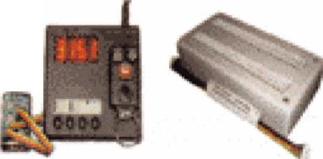

Welcome to our new monthly feature! Each month we will highlight a current ALOA Convention and Security Expo exhibitor with product information or important developments and innovation that you can use in your security-related business. To be considered or to recommend an exhibitor; please send an email to Kim Hammond at [khammond@cdibb.com](mailto:khammond@cdibb.com).



W# **Umm** rtmo4**m,.,** w you ckin’1 husv** !«'

Security Systems

wwwjuto*ecte-e«n

**AutoTech Security Systems  
3732 Grissom Lane  
Kissimmee, FL 34741  
888-252-8324**

Growing up we are taught the Golden Rule; "Do unto others as you would have them do unto you!" The principle is applied across every culture, race, nationality and status. Everyone is not the same, but deserves the same respect and considerations. When some­one starts a business, they are trying to do two (2) things; keep the doors "open" & make a profit. There is nothing wrong with making a profit by being a supplier or "middle­man". You usually take on the financial responsibility of carrying inventory, tech support, etc. You wouldn't be in business very long if you gave the same price and service to a re­tail and wholesale customer. Your level of kindness and consideration should be same but your priority needs to be to the wholesaler!

Are you being treated like a professional who is buying a product for resale, or are you treated like a retail customer by your supplier? Like it or not, you are a customer to your supplier. You are designated by an account name or number but you are MUCH MORE than that. You are also a trained, qualified professional. As a seller, you should be more informed, offer the correct item for the job, make suggestions, discourage poor quality and teach your customer how to properly use their product.

The old adage, "the customer is always right!" has been burned into our minds. It is a standard by which we do business. The reality is, as business owners, we convince the customer what they got is what they wanted and therefore perpetuate the image that they are "always right". By creatively manipulating the way things are presented, the customer feels that they got their way. Let's make this perfectly clear. We are not talking about lying, cheating, or falsifying anything. But from the moment you opened your door for business, your mentality changed from that of a retail customer to a retail sales expert.

If your customer were to go directly to the supplier, they should not be given the same benefits as you, especially where price is con­cerned. You are trusted to get better pricing than the retail client. You should make a decent profit if you sell to the customer your­self. Commonly known as the mark up, you have a right to pay less than your customer.

You deserve to have the best information about the products you buy. It is in your supplier's best interest to inform you of all your options when choosing a product. This can be a sign of the sup­plier's commitment to your success. As the saying goes "People don't care how much you know until they know how much you care!". The supplier is all too often aware of the fact that some­times an inferior product will end up "biting you in the (fill in your own word)". Therefore, you will probably come back and blame them for selling you the wrong product. If they educate you about the positive as well as the negative sides of the product then you are more likely to trust them and buy what they recommend. This becomes a win-win situation. If you are just being sold a product without the proper support, then you have a problem. The key to successful business with a supplier is communication. It is great if you understand the product's attributes but sometimes the right ad­vice from a knowledgable saslesperson can be just what you need to complete the job.

What products does your supplier offer? Better yet, what do they offer that will help you? You are the reason your supplier is in busi­ness. If they have a special price on "widgets" for an unbelievable savings but you have to buy in large quantities to get the savings, then what do you really gain? You could end up with a closet full of widgets and no one to buy them. If the market is crying out for thing-a-ma-jigs and widgets, don't be deceived by a supplier who tells you "don't worry about the thing-a-ma-jigs just sell the widg­ets". because you will only be limiting your possible profits. For example, in the remotes aspect of the access control business,

40% of all remotes are sold as aftermarket pproducts (Keyless Entry, Alarms, Remote Starters). Still, most suppliers only focus on Factory/OEM. That is a huge and unnecessary loss of revenue, especially when you consider there isn't any need for specialty tools to program aftermarket remotes.

The market has been driving sales since the very beginning. This creates the time-proven equation of supply and demand. If you do your homework, like you should, you can make quality decisions based on facts.

The world is full of things that 'LOOK' awesome on the outside, only to find they lack substance when examined closely. Think of all the toys you played with as a child. You were awed by prom­ises and glitzy advertising that said "SOLID, DURABLE, STRONG, LONG LASTING and BUILT TO LAST". You were lucky if it stayed together, didn't break, chip, crack, peel, etc. Thus, teaching us the lesson, "you get what you pay for". As we get older, it is ex­pected that we might learn this lesson. However, we still fall prey to the tactics of companies that use clever, colorful, and even de­ceptive advertising. As a professional, it is your responsibility to research any product or service you buy. The time you take to in­vestigate and learn about a company's methods, integrity, prod­ucts, etc., can save you hundreds if not thousands in dollars and headaches.

Although it is critical you check out the company you are looking into, it is just as important to check out the competition of that com­pany. You may save money in the process and you will assuredly have a clearer picture of how the industry operates. Make a few phone calls, ask questions, and most importantly, make sure you are comparing "apples to apples" as you go. Don't be fooled by the statement "it's just like....," only later to find it really wasn't the same thing at all. Maybe it is and maybe it isn't, you have to look carefully at the details when you compare.

It is the responsibility of your supplier to have the integrity to give you accurate and honest answers. Make sure you clearly under­stand the benefits as well as the downside of the product or serv­ice. Distributors, manufacturers, suppliers, etc. would like to say there isn't any downside to their product or service but we all know that nothing is perfect.

As locksmiths you are aware of the over abundance of "fly-by- night" companies. (I won't even give them the respect of calling them locksmiths). These shady imposters are causing an image problem for your honorable profession. When it comes to re­motes, it is no different. There are several companies out there of­fering remotes, some good some bad. So, if you are sure of which remote you need, have the capability of programming it and are sure you won't need any technical support, then you can take the chance (a big one) that they will send you the right one. The unfor­tunate facts are, many of the companies available have limited knowledge of the remotes and their systems, offer little or no war­ranty, no guarantee and may not even be in existence when you need to return the item. Some of the companies may have an im­pressive website(s) with all the bells and whistles, but they lack ac­curate information. With these suppliers, you could go to program the remote and find you have the wrong product! You are then stuck, confused and look like a fool. Some companies provide the right information but don't stock an adequate supply.

A good supplier stands the test of time. As you compare, you will find some things are more tailored to you than others. Build a working relationship with your chosen suppliers. Personal or pro­fessional differences may lead you away from one, while common values and goals may draw you closer to another. The bottom line is you need to find the company that "fits you".

I have been asked, why I wrote this article in this form instead of just "selling ourselves"? Why isn't there any specific references to our products, tools, services, etc? The answer is, I already wrote over 7 articles dealing with selling remotes, cloning remotes, mar­keting, even why locksmith's are hesitant about selling them. I think the point has been made: You need to be selling remotes if you are an automotive locksmith. The real question now is "WHERE DO YOU GO FROM HERE?"

It is time to do your homework! If I can be of any assistance or if you have any questions please don't hesitate to contact me by phone: (888) 252-8324, fax: (800) 980-6713 or E-mail: [Brent@autotechs.com](mailto:Brent@autotechs.com). I don't have all the answers, but I will do my best to help you.

**21**

Keynotes • November 2007

Door lock or Safe Lock?

By Greg Perry, CML, CPS

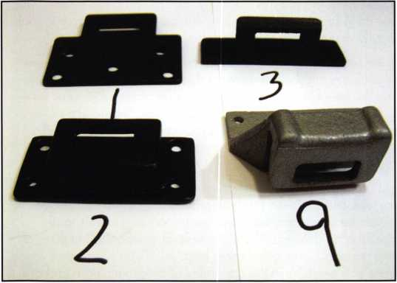

photo. 1

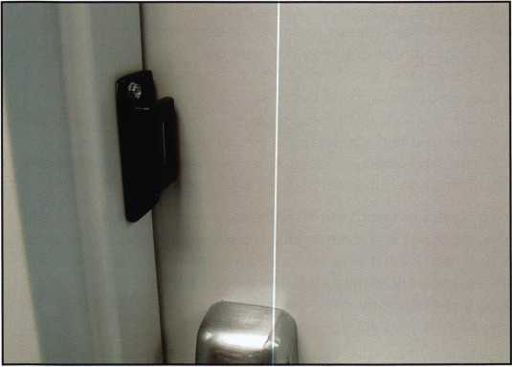

photo. 2

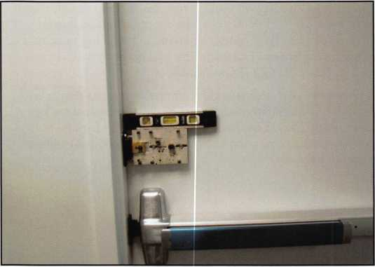

photo. 3

I need an X09 lock installed the caller says.

They may have gotten your name from the Kaba-Mas factory or perhaps an industry acquaintance. A simple request but when the call comes from a building con­tractor chances are that they really want a CD-X09. Whats the difference some of you might ask? The X09 is a safe lock slightly modified and installed in an exten­sion to become the CD-X09 or Combination Deadbolt for pedestrian or standard doors. So is this a request for a safe technician or a locksmith? I believe it’s both. The lock installs on a regular door so you need the skills of a locksmith but since it uses a safe lock, the X09 requires the skills of a safe technician. This article will look at the installation of both an X09 and the CD-X09.

The requirements for the X09 are listed in FF-L2740A. At the present time only 3 locks have been approved: the X07, X08 and X09. All of these have been or are made by MasHamilton which after being purchased by Kaba is now KabaMas. The requirements for the pedestrian door deadbolt is listed in FF-L-2890A. There are four different specifications. Type 1 is the key lock life safety feature; type II, keyless life safety feature; type III, ADA/UFAS compliant; and type IV ADA/UFAS com­pliant with access control interface. ADA stands for Americans with Disabilities Act, UFAS stands for Uni­form Federal Accessibility Standards. Both of the FF-L standards can be found at the DOD Lock Program web site <https://portal.navfac.navy.mil/go/locks>, from the Documents and Forms tab, choose the Federal Specifica­tions and QPL’s to view the list of relevant documents

Keynotes • November 2007

including FF-L2740A and FF-L2890A. Many other DOD safe and vault re­quirements can be found at this site.

How does this lock get installed? First question before even ordering the lock is which strike is needed? The hand of the door and double or single door needs to be known to get the right strike. Alternatively if you perform many installs. Keep one of each strike on hand. The four different strikes are pictured in photo 1, their usage is as follows: Number 1 is for an inswing door with a wood frame. Number 2 is for an outswing door. Number 3 has two different applications, first an in­swing single door with a metal frame or

**First question before even ordering the lock is which strike is needed?**

sometimes on a wood frame applica­tion, the other is for a set of inswinging double doors. The final strike you might think should be a number 4 but you’re wrong it’s a number 9 and is used for outswinging double doors. Caution your customer when using a number 9 strike, it will break if the in­active door is opened prior to opening the active side.

Once you have the right strike for the

application it is time to begin the in­stallation. Using a template will make the installation go a lot smoother but it’s not required. Two different tem­plates exist first the one used in this in­stallation was designed for the original CD-X07. This lock did not require the use of the outside mounting plate. At that time it was an option. We’ll look at the mounting plate a little later. The six screw hole drill guides are 9/64”. This means you need to re-drill four of the holes larger for the studs of the outer mounting plate. The other model available has the proper size drill guides for all six holes. I find it best to mount the strike first when using the number 1 or 2 strikes and after when using the number 3 or 9 strikes. When using the number 1 or 2 strike place the template on the door and position the strike on the frame in the proper location. Drill and install one screw to hold the strike and double-check your location before installing a second screw. The balance of the screws are best installed at the end of the lock in­stall. The tolerance is very tight be­tween the strike and the lock is very tight, perhaps about .050, not a lot of room for error. If you are using the number 3 or 9 strike hold the strike in position as you mount the template to find the proper position and verify the clearance as you open and close the door. This install involved using the number 2 strike so it was installed first as seen in photo 2. I also like to use a

Keynotes • November 2007

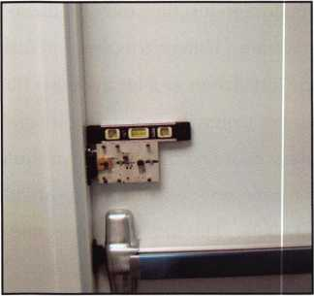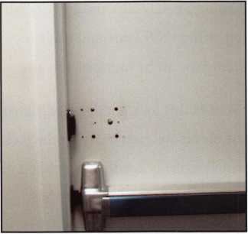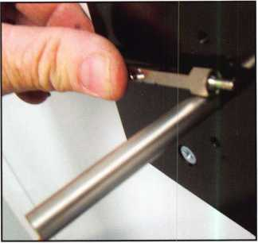

photo. 4 photo. 5

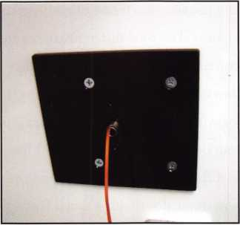

photo. 7 photo. 8

photo. 6

photo. 9

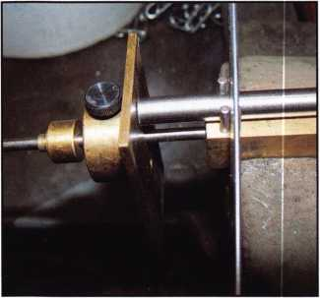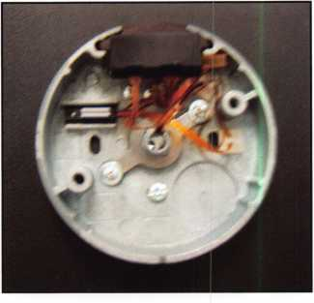

thin shim or thin washers under the strike to move the tem­plate further away on the door. This allows for a little wig­gle room, its easier to shim the strike, because you cant remove material on the back of the strike if you get it a little too close.

Once the strike was mounted the template was positioned on the door using a level to assure a clean straight look as seen in photo 3. I like to drill the six screw holes and the 7/16” spindle hole from the inside. Then insert the 7/16” bit from the outside to align the template and again using the level to position the plate I’ll drill the four outside through bolt holes as seen in photo 4. The four appropriate holes are now enlarged in photo 5 to 3/8”. The next step is to place the outer tube and the inside hardplate on the lock and then onto the door. Typically it is easiest to use the two screws closest to the edge of the door to hold this package in place. Next install the outer plate seen photo 6, the

outer tube will be protruding through the plate. This pic­ture is a little deceiving, the outer plate cover should be in place before measuring for tube length. The spindle nut can be used to measure since it uses 5/16” nut. Once marked the outer tube can be cut and the cutoff portion is now used to mark the inner tube and it is cut. A DRAT or Dial Ring Alignment Tool seen in photo 7 can be used to measure the tube length on a safe and also comes with a tube holding fixture. It is far superior to the rubber block that comes with the lock. Both tubes need to be deburred using the provided stone. Next clean the tubes both inside and outside using a tissue or a piece of foam. The lock should then be removed and tubes properly installed prior to reinstalling it back on the door. Make sure the inner tube cap in the dial ring base is aligned correctly and install the base. Your next step is to route the wires away from the motor location and the spindle. Photos 9 and 10 show two



Keynotes • November 2007

associate

members

**CompX Security Products**

Phone: 864-297-6655 Fax: 864-297-9987 [www.compx.com](http://www.compx.com)

**D&D Technologies (USA), Inc.**

Phone: 714-677- 1300x292 Fax: 714-677-1299 [www.ddtechglobal.com](http://www.ddtechglobal.com)

**DETEX Corp.**

Phone: 800-729-3839 Fax: 830-620-6711 [www.detex.com](http://www.detex.com)

**Don-Jo**

**Manufacturing, Inc.**

Phone: 978-422-3377 Fax: 978-422-3467 [www.don-jo.com](http://www.don-jo.com)

**Door Controls International**

Phone: 800-742-3634 Fax: 800-742-0410 [www.doorcontrols.com](http://www.doorcontrols.com)

**Doorking Inc.**

Phone: 800-826-7493 Fax: 310-641-1586 [www.doorking.com](http://www.doorking.com)

**Dorma Architectual Hardware**

Phone: 717-336-3881 Fax: 717-336-2106 [www.dorma-usa.com](http://www.dorma-usa.com)

**DynaLock Corp**

Phone: 860-582-4761 Fax: 860-585-0338 [www.dynalock.com](http://www.dynalock.com)

**FireKing Security Group**

Phone: 800-457-2424 Fax: 800-896-6606 [www.fireking.com](http://www.fireking.com)

**Framon Manufacturing Company Inc.**

Phone: 989-354-5623 Fax: 989-354-4238 [www.framon.com](http://www.framon.com)

**G-U Hardware Inc.**

Phone: 757-877-9020 Fax: 757-877-9720 [www.g-u.com](http://www.g-u.com)

**HPC, Inc.**

Phone: 847-671-6280 Fax: 847-671-6343 [www.hpcworld.com](http://www.hpcworld.com)

**HY-KO Products Co.**

Phone: 330-467-7446 Fax: 330-467-7442

**Hammerhead Industries, Inc.**

Phone: 805-658-9922 Fax: 805-658-8833 [www.gearkeeper.com](http://www.gearkeeper.com)

**Ingersoll Rand**

**Security**

**Technologies**

Phone: 317-810-3801 Fax: 317-805-5779 [www.schlagelock.com](http://www.schlagelock.com)

**Jackson Corporation**

Phone: 323-269-8111 Fax: 800-888-6855 [www.jacksonexit.com](http://www.jacksonexit.com)

**Jet Hardware Mfg., Co.**

Phone: 718-257-9600 Fax: 718-257-0973 [www.jetkeys.com](http://www.jetkeys.com)

**KABA ILCO Corp.**

Phone: 252-446-3321 Fax: 252-446-4702 [www.kaba-ilco.com](http://www.kaba-ilco.com)

**KEY-BAK/West Coast Chain Mfg.**

Phone: 909-923-7800 Fax: 909-923-0024 [www.keybak.com](http://www.keybak.com)

**Kenstan Lock Company**

Phone: 516-576-

9090x315

Fax: 516-576-0100

[www.kenstan.com](http://www.kenstan.com)

**Keri Systems Inc.**

Phone: 408-435-8400 Fax: 408-435-7163 [www.kerisys.com](http://www.kerisys.com)

**Kustom Key Inc.**

Phone: 800-537-5397 Fax: 800-235-4728 [www.kustomkey.com](http://www.kustomkey.com)

**LAB Security**

Phone: 800-243-8242 Fax: 860-583-7838 [www.labpins.com](http://www.labpins.com)

**Lucky Line Products, Inc.**

Phone: 858-549-6699 Fax: 858-549-0949 [www.luckyline.com](http://www.luckyline.com)

**M.A.G.**

**Manufacturing**

Phone: 714-891-5100 Fax: 714-892-6845

[www.magmanufacturing.com](http://www.magmanufacturing.com)

**MPT Industries, Inc.**

Phone: 973-989-9220 Fax: 973-989-9234 [www.mptindustries.com](http://www.mptindustries.com)

**MUL-T-LOCK USA, Inc.**

Phone: 800-562-351 1 Fax: 973-778-4007 www. mul-t-lockusa .com

**Maxcess Card Systems Inc**

Phone: 800-713-4823 Fax: 650-692-9410 www. maxcess-card .com

**Medeco Security Locks**

Phone: 540-380-5000 Fax: 540-380-5010 [www.medeco.com](http://www.medeco.com)

**Mil-Comm Products Co Inc**

Phone: 201-935-8561 Fax: 201-935-6059

**Pacific Lock Company**

Phone: 888-562-5565 Fax: 818-678-6600 [www.paclock.com](http://www.paclock.com)

**Protex Safe Co., LLC**

Phone: 818-610-8030 Fax: 818-610-8004 www. p rotexsa fe.com

**RA-Lock Company**

Phone: 800-777-6310 Fax: 972-775-6316 [www.ralock.com](http://www.ralock.com)

**ROFU International Corp.**

Phone: 800-255-7638 Fax: 253-840-7272 [www.rofu.com](http://www.rofu.com)

**Rutherford Controls Int'l Co.**

Phone: 519-621-7651 Fax: 519-621-7939 [www.rutherfordcontrols.c](http://www.rutherfordcontrols.c) om

**Sargent &**

**Greenleaf, Inc.**

Phone: 859-885-941 1 Fax: 859-885-3063 www. sa rgenta ndg reen- leaf.com

**Sargent**

**Manufacturing Co.**

Phone: 800-727-5477 Fax: 888-863-5054 [www.sargentlock.com](http://www.sargentlock.com)

**Schwab Corp.**

Phone: 765-447-9470 Fax: 765-447-8278 [www.schwabcorp.com](http://www.schwabcorp.com)

**Securifort Inc**

Phone: 819-359-2226 Fax: 819-359-2218 [www.securifort.com](http://www.securifort.com)

**Securitron Magnalock Corp.**

Phone: 775-355-5625 Fax: 775-355-5636 [www.securitron.com](http://www.securitron.com)

**Security Door Controls**

Phone: 805-494-0622 Fax: 805-494-8861 [www.sdcsecurity.com](http://www.sdcsecurity.com)

**Security Solutions**

Phone: 405-376-1600 Fax: 405-376-6870 [www.securitysolutions- usa.com](http://www.securitysolutions-usa.com)

**Select Engineered Systems**

Phone: 305-823-5410 Fax: 305-823-5215 [www.selectses.com](http://www.selectses.com)

**Townsteel, Inc.**

Phone: 626-858-5080 Fax: 626-858-3393 [www.townsteel.com](http://www.townsteel.com)

**Trine Access Technology**

Phone: 718-829-2332 Fax: 718-829-6405 [www.trineonline.com](http://www.trineonline.com)

**Videx Inc.**

Phone: 541-758-0521 Fax: 541-752-5285 [www.videx.com](http://www.videx.com)

**WIKK Industries Inc.**

Phone: 414-421-9490

Fax:414-421-3158

[www.wikk.com](http://www.wikk.com)

**WMW Innovation Company**

Phone: 888-474-2341 www. su re-str i ke.com

Service

Organization

**Allstate Insurance Company**

Phone: 847-551-2181 Fax: 847-551-2732 [www.allstate.com](http://www.allstate.com)

**HRH Insurance**

Phone: 817-462-3630 Fax: 817-462-3680 [www.hrh.com](http://www.hrh.com)

**Red Hawk**

Phone: 901-332-291 1 Fax: 901-332-2878 [www.webstersinc.com](http://www.webstersinc.com)

**The Mechanic Group, Inc.**

Phone: 845-735-0700 Fax: 845-735-8383

[www.mechanicgroup.com](http://www.mechanicgroup.com)

Keynotes • November 2007

**3**

**CORRECTION**



***KEYNOTES*** - ***NOVEMBER 2007***

**ALOA TAKES PHONY LOCKSMITH ISSUE STRAIGHT TO THE ATTORNEY GENERAL**

ALOA's Legislative Manager, Tim Mc­Mullen, JD, CAE was invited once again by the National Association of Attorneys General (NAAG) to make a presenta­tion regarding phony locksmiths at their Consumer Protection meeting in Boston. Tim addressed the Assistant Attorneys General in charge of Consumer Protec­tion for over 40 states and the District of Columbia.

In his presentation, Tim highlighted the work that ALOA has done with enforce­ment officials and leading consumer groups on protecting consumers from "phony locksmiths." Many states are taking a stance to combat this problem.

In San Mateo County, California, the Chief Deputy District Attorney prose­cuted a man posing as a locksmith after he bilked an 86-year-old homeowner, and possibly several others. The man was sentenced to three months in prison and three years' probation. See "Man sentenced for fraudulent locksmith scheme" (San Mateo County Time) at [http://origin.insidebayarea.com/san- mateocountytimes/localnews/ci_70053](http://origin.insidebayarea.com/san-mateocountytimes/localnews/ci_70053) 06 and also "Unlicensed Locksmith En­ters No Contest Plea" (KGO-TV, San Francisco) at

http:/ / abclocal.go.com/kgo/story?sec- tion=7on_your_side&id=5621 140.

In Georgia, the Office of Consumer Af­fairs initiated a suit against a locksmith

in Atlanta for unfair and deceptive acts as unlawful under the Fair Business Prac­tice Act. The respondent was willing to enter into an "Assurance of Voluntary Compliance," and the state fined the company over $105,000 in court ex­penses and civil penalties.

States are also cracking down on the phony locksmith epidemic by raising the fine for operating without a license. While the companies themselves may have a company license, they use tech­nicians who do not. In Illinois, they changed the fine from $1,500 to $10,000 for each violation of the act (including deceptive acts and false ad­vertising). In Texas, they raised the fine from $ 1,000 to $ 10,000 for each viola­tion (see CORRECTIONS below).

ALOA is also working with the Better Business Bureau to alert consumers of this scam. Check out "What's the Key to Finding Reputable Locksmiths" (KTVT- TV, Dallas, TX) at:

<http://cbsl> 1 tv.com/video/?id=22142 @ktvt.dayport.com&cid=7.

ALOA asked the Attorney's General to post ALOA's 1 0-point checklist for con­sumers to detect companies that may be engaging in this scheme. ALOA let them know that they are willing to work with Consumer Protection Divisions to improve the enforcement and informa­tion exchange among the states with re­spect to investigations, litigation and consumer education.

The latest Legislative Reports have failed to include Texas H.8. 2833 which changed requirements of the background check and also raised the fine for each violation of oper­ating without a license from $1,000 to $10,000 (intended to go after the phony locksmiths). Also, Illinois SB 1424 now requires that any locksmith without employ­ees to register their business name under the Assumed Business Name Act or must hold an agency license in the business name. As always businesses with employees must have any agency license in the business name. The Department of Professional Regulation may now adopt rules of continuing education for persons licensed under the Act. The Department shall consider the recommendations of the Board in establishing guidelines for the con­tinuing education requirements. The Department with the approval of a member of the Board, may sub­poena and bring before it any per­son to take the oral or written testimony or compel the production of any books, papers, records, or any other documents that the Sec­retary or his or her designee deems relevant or material to any such in­vestigation or hearing conducted b y the Department. Changed from $ 1500 to $ 10,000 the fine for vi­olating the act (including deceptive acts and false advertising) - again, intended to go after phony lock­smiths.

£Q| Keynotes • November 2007



for renewing.

YOU ARE PART OF A NETWORK OF MORE THAN 8000 OF YOUR  
PEERS WHO ARE DEDICATED TO THE ADVANCEMENT OF  
THE LOCKSMITH/ACCESS CONTROL INDUSTRY.

As a result of the 2007 Membership Survey, ALOA is poised to deliver more exciting and unique member benefits to help meet the expectations you have outlined. ALOA is excited about all of the new changes that are in-store for all of our members in 2008.

Be on the lookout for:

* Continuing enhancements of ALOA’s website including better access to your member profile; online registration for the convention
* Increased visibility of your ALOA affilia­tion

• Exciting new features in Keynotes - “Member Spotlight”, “Exhibitor Spotlight”, “The Locksmith’s Guide to Better Busi­ness” and accessible online and so more more

• Coming soon - online PRP testing sites

i H'*

And don>’t forget to take advantage of:

•Your affiliation, which opens many doors for you and your business

I

•A free $10,000 bond (ALOA active mem­bers only)

* Your 10% discount coupon in the ALOA store filled with books and new merchan­dise to help your business grow
* Up to $ 300 savings on ALOA 2008 con­vention registration
* Free advertising opportunity with your listing on “Find A Locksmith”
* More training and education opportuni­ties, including discounts on education

ALOA is your representative working for the

advancement of the locksmith/access con-

trol industry and the welfare of its

members. ALOA is YOUR voice in

dustry; make sure to take advan

everything that is available to

member.

Associated

3500 Easy Street * Dallas

Phone: 800-532-2562

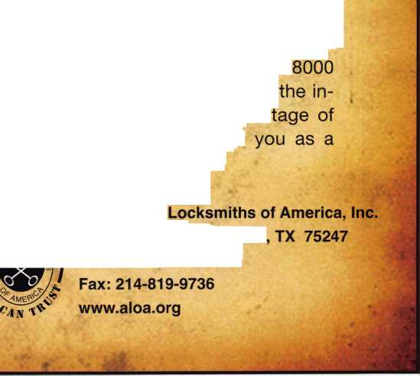

YOUR COMMITMENT TO ALOA BOARD SERVICE

(Please read carefully and sign where indicated.)

The ALOA Board governs with emphasis on organizational vision rather than on interpersonal issues of the Board; en­courages diversity in viewpoints; focuses on strategic leadership rather than administrative detail; observes clear dis­tinction between Board and Executive Director roles; makes collective rather than individual decisions; exhibits future orientation rather than past; and governs proactively rather than reactively. (For a copy of the ALOA Board of Directors Governance Policy contact the ALOA headquarters office or visit [www.aloa.org](http://www.aloa.org).) The responsibilities of an ALOA board member include contributing a moderate amount of personal time, and a significant degree of professional guidance and expertise to the organization.

You will be expected to come to board meetings and the annual membership meeting. You will need to be prepared to sensibly discuss matters of great importance to your profession and participate in setting policy as part of a governing body. Your course of action during your tenure on the ALOA board should be guided by fair minded, constructive goals pertaining to matters of consequence for ALOA and for the industry. Your contributions are expected to benefit ALOA as a whole, taking individual member rights and concerns into account, but free of the taint of partisan politics or personal gain.

On a practical note: ALOA board members are expected to behave and dress professionally at all times, especially when actively representing the association. ALOA board members are required to participate in two board meetings per year, of three or four days in length, one each fall and spring. Board members are also asked to attend the annual convention and are required to attend the annual membership meeting. Incoming Board Members are required (at their own expense) to attend the annual convention. Immediately following their election, Board members may also be asked on a voluntary basis, to represent ALOA at related local, state or regional functions, including serving in the ALOA Booth and otherwise promoting ALOA. When travel is required for a board member, expenses covered by ALOA include lodging, travel and a reasonable per **diem.** The Board has stipulated that assigned travel will be reim­bursed at the lesser of the 30-day advance tourist class airfare in effect at the time of travel or the current per-mile rate for travel by personal automobile. Spouse expenses, including extra room charges, etc., are the individual's responsi­bility.

• • •

I have read and agree to adhere to the ALOA Board of Directors Governance Policy. Furthermore I understand the above responsibilities of an ALOA board member, and agree to commit my time and energies as needed. I certify all of the information contained on this form and supporting documentation to be true and complete.

I can be contacted with questions at:

|  |  |
| --- | --- |
| Address | Phone # |
|  | |
| Signed: | Date |
| Print Name: | Member # |

Please attach a recent photograph of yourself along with a 75 word or less biography and retain a copy of this form for your own files. This form and all supporting documentation should be submitted no later than Feb­ruary 1,2008. Mail or Fax to:

Nominee Profile

Secretary of the Board of Directors  
John Soderland  
5124 West Howard Ave.

Milwaukee, Wl 53220  
414-327-5625  
Fax: 414-587-2038

Fall 2007 Board Meeting Summary

Your Board of Directors (BOD) met at the Willowbrook Holiday Inn in Chicago Illinois October 12th through the 14th, in conjunction with the Institutional Locksmith Association's Convention (ILA). We would like to thank the members of the ILA for their hospitality. Bob Mock and Bobby DeWeese were excused from this meeting for family reasons, and we would like to congratulate our newest DAD on the Board, Tom Gillingham. Tom and Kathy's daughter was born soon after this year's convention.

During our meeting, the governance policy was reviewed to make sure it is kept up to date. The governance policy is used to direct the opera­tion's of ALOA . The BOD has adopted this policy as the structure by which our staff in Dallas runs our association. Since this policy has been effect, ALOA has been much more efficient. In the past Board meetings used to be week-long committee meetings, now we can ac­complish our agenda in two days.

During the fall BOD meeting, each director gave a written or oral re­port on their Board related activities since convention. Everyone has been very busy visiting our membership at local association meetings and tradeshows. If you would like to have a Board member attend a local function please email your regional director or [president@aloa.org](mailto:president@aloa.org).

ALOA's activities with the National Automotive Service Task Force (NASTF) will soon make key codes and transponder information (which is necessary to make keys for automobiles)available soon. Up to date information on NASTF is available on the ALOA's website.

The President has requested from our membership, ideas that might help the association grow. We have already received very good sub­missions from several members. These ideas were discussed, and you will soon see new programs and changes as a result.

To highlight some of the new things you may have already seen or will soon see are improvements to Keynotes. This is how our membership is kept informed of happenings within the organization as well as some of the best technical articles written. Keynotes is now available on our website [www.aloa.org](http://www.aloa.org) under the members only section. Keynotes now features a new department called "Member Spotlight." This department was added to highlight member accomplishments, services and abili­ties. Another new department, "Exhibitor Spotlight" was added in Octo­ber 2007 to give Associate Members and Exhibitors a chance to share new technology and product news with the readers. A Buyers Market­place was added to give the reader a quick guide to products and services.

A Membership report by Ellen McEwen will now appear in each issue. This article will update the reader on marketing initiatives, member ben­efits and special incentives.

In keeping with the goals set by ALOA's new President, Keynotes will now feature a monthly business article from a series entitled "The Lock­smith's Guide to Better Business" by member, Vernon C. Bedore, CRL. These articles will run beginning in January 2008.

Keynotes will also feature an entertaining new monthly department which includes a crossword puzzle that is specifically tailored to the in­dustry and our members.

The editorial calendar is being revised to update categories and themes. This will help with sales and marketing to advertisers and possi­bly attract themed features to increase article submissions.

We will be looking into creating a new PRP program for locksmiths that primarily work within the automotive field. This will help attract new members as well as give existing members a new program to keep their continuing education requirement current.

Our new website should be online shortly after the first of the year. The new website will allow for online registration for convention, updating of current records on file with ALOA, including addresses, phone num­bers, email addresses and a new forum section for member use. Only one password will be needed to access all sections of the site. A new video will also be available that highlights some of the reasons to be a member of ALOA.

The Board spent a lot of time on how to combat the new problems of "phony locksmiths." On ALOA's website there is a link for consumers to file a complaint with their local state's Attorney General Consumer Pro­tection website. Please spread the word on this. The more complaints we can register, the easier it will be for us to get results. We even re­moved two attendees from the show floor this year, because they were related to some of the phony locksmith companies.

The Board has developed a new Prospective Board member handbook for those who are interested in devoting time to make this great associ­ation better by joining our Board. It explains how the board works by using the governance policy and responsibilities of board members. Election guidelines were developed for nominees of future elections to provide them information on what resources are available, to help with their campaign.

Some time was spent exploring the ends (goals) of our association and how to plan our vision for the next 5 to 10 years. Several ideas were discussed and committees were set and directed to explore further so that we can review these at our spring meeting.

A plan was developed to increase membership. For 2008, whoever sponsors a new person for the association will be given $25 once that person is approved for active membership. This will be limited to 20 sponsorships per person during this year.

There will also be a contest this year to come up with a new, more cur­rent name for our organization. There is a segment of our membership and the public that would like for us to conform to the current market. Our members work on more than just locks; we are security profession­als. Look for more details in Keynotes. Grand prize for the winning entry is a complete convention package. We look forward to your sug­gestions.

We will also have a contest at the kick off party at convention. We will ask for submissions of the best website, best storefront, best looking van, and many more. Members at convention will have the opportunity to vote for the top entries. Look for more details on this promotion also in Keynotes.

Look for online testing coming soon. You will have the opportunity to take PRP tests at several easily accessible testing facilities. Results of the test will be posted immediately.

These new programs are very exciting and will allow the membership to become more involved in the association. The Board is very excited about these new ideas that have been suggested by our members. If you have any ideas that you feel will also help the organization, please email them to our President at [president@aloa.org](mailto:president@aloa.org) for consideration at our next Board meeting.

Thank you.

**Classifieds**

EMPLOYMENT

LOCKSMITH WANTED

Busy shop in Woburn, Massachusetts seeks experienced Locksmith. We per­form commercial, residential, safe, glass storefronts, card access and automotive work including 2 AAA accounts. You don't have to know all these phases of locksmithing and we are also willing to train if interested. Sub contractors wel­come - your van or ours. For more info please contact John at 781-933-9999 or send resume to:

Locks & Keys, Inc., P.O. Box 222, Woburn, AAA 01 801.

LOCKSMITH WANTED

Established company with 30+ years in business in Hampton Roads, Virginia is seeking locksmith with experience in res­idential, commercial, and automotive work. Knowledge in servicing safes, medeco locks and electronic access con­trol a plus. Applicant must be neat in appearance self motivated, have good driving record and be able to pass background and drug testing.

We offer full benefits package, competi­tive wages, medical insurance, paid va­cation and sick days, education and profit sharing. Send resume to: Shorty Wallin Lock and Security. Fax 757-722- 5520 or email to: [swallin@shortywallin.com](mailto:swallin@shortywallin.com)

LOCKSMITH TECH NEEDED

Need energetic Locksmith Tech with good working skills, computer experi­ence and warehouse skills a plus!!!!! Hours: Mon-Fri, 8am-5pm Good driving record required. Retire­ment Plan, Health Insurance, Salary Ne­gotiable. Established, well known company in business since 1964.

Sword Company, 6525 South Broad­way, Tyler, Texas 75703 Ph: 903-561-

1961. Send resume to Fax 903-561-4932 or email: [mike@swordco.com](mailto:mike@swordco.com)

SALES PERSON NEEDED

Nevada Lock Supply, a wholesale lock supply company located in beautiful Las Vegas, seeks a front counter sales per­son. Must have 2 years of lock experi­ence and good communication skills. Competitive salary and benefits pack­age. Contact John at [jmiers@nevadalock.com](mailto:jmiers@nevadalock.com)

LOCKSMITH - STORE MANAGER WANTED

New Locksmith store opening October in Aventura, Florida. We are looking for an experienced locksmith to run the store. Great opportunity for the right person. Qualifications: Experienced Locksmith and knowledgeable about hardware. Retail store experience. Can do estimates and sell jobs. Interact and communicate well with clients. Bilingual - English/ Spanish. Self-starter and problem solver. Locksmith's License, Dri­ver's License. Salary Open. Email: [aviva@soslockmith.com](mailto:aviva@soslockmith.com)

LOCKSMITH WANTED NEW YORK CITY

Experienced Locksmith and knowledge­able about hardware. Can do estimates and sell jobs. Interact and communicate well with clients. Locksmith's License, Driver's License. Manhattan Location. Salary Open, [aviva@soslockmith.com](mailto:aviva@soslockmith.com)

LOCKSMITH OR APPRENTICE - BOZEMAN, MONTANA,

THE BEST PLACE

Bozeman Safe & Lock is a provider of security hardware, systems, and serv­ices in the south central region of Mon­tana. We are the region's market leader in developing professional and effective

security soluctions to diverse commer­cial, residential, and safe problems. Consider being part of our team! Visit our website at [www.bozemansafeand- lock.com](http://www.bozemansafeand-lock.com). Appropriate certification(s) a plus. Competitive salary, benefit pack­age. Call Rich at 406-570-5134 or email: [rich@bozemansafeandlock.com](mailto:rich@bozemansafeandlock.com).

EXPERIENCED LOCKSMITH NEEDED - SIGN-ON BONUS RELOCATION ASSIS­TANCE

60 year old Austin, Texas company with 5 locations and 29 service vehicles is seeking experienced technicans as well as shop management candidate. We offer competitive wages based on expe­rience, commissions, overtime, medical benefits, 401 k, cafeteria plan, paid va­cations, sick leave and holidays. We supply the vehicle and tools, you supply the talent. Our customers are residential, commericial and industrial and institu­tional. We also do access control,

CCTV, and alarms. Opportunity for edu­cation, growth and advancement is tremendous. The right candidates will be given a 'sign on" bonus. Relocation as­sistance is also available. Must be able to meet requirements of State of Texas for licensing. If interested, send resume to: [jimh@cothrons.net](mailto:jimh@cothrons.net) or fax to 512- 459-2828.

SALES REPRESENTATIVE WANTED JMA, USA, a leading European key manufacturer is looking for sales repre- sentatatives for various US territories.

The sales representative will be responsi­ble for managing existing accounts in each territory and to open new ac­counts. Please send resume to Mike Ripoll, email address: mripoll@jmausa. com.

Keynotes • November 2007

EXPERIENCED LOCKSMITH WANTED Established company, Bend Oregon requires full time locksmith. Ex­perienced in commerical, residential and auto. Must be motivated team player. Paid vactiona, hoidays and benefits. Email [bedlocksafe@bend- broadband.com](mailto:bedlocksafe@bend-broadband.com) or call Mary at 541-948-6073.

LOCKSMITH WANTED High volume mobile/storefront shop in San Dimas, CA. We are seeking a tech­nician for a full time position servicing Residential, Commerical, and Automo­tive. We are willing to train a self moti­vated person with some experience. Good driving record requiried. Retire­ment Plan and Health Insurance avail­able. Call Chris at 909-599-3178 or email [chris@sanderslock.com](mailto:chris@sanderslock.com)

LOCKSMITH OPENINGS AT GEORGIA TECH

The Housing Department at the Georgia Institute of Technology (Georgia Tech) has recently acquired four additional buildings with living space for an additional 2,000 students. (The Former Olympic Village) To help manage the additional workload that this and other campus improvements will require, we will be hiring 2 additional Locksmiths for the Georgia Tech Housing Department here in Atlanta. Follow this link for more info, [https://ea.ohr.gat- ech.edu/FullDescription.asp?jobid=BJJ6](https://ea.ohr.gat-ech.edu/FullDescription.asp?jobid=BJJ6) 743&type=4&typeofjob=ext&jobtitle=L OCKSMITH%20I

WANTED TO BUY/SELL

MOBILE LOCKSMITH BUSINESS FOR SALE

In Kansas City area. Well established with loyal customers. Strong with banks and schools. One person business with plenty of room for expansion opportu­nity. Great reputation! Owner retiring.

Call Bob Badgley 1-800-966-2005 FOR SALE -

LOCKSMITH BUSINESS

Locksmith Business near southwest sub­urbs of Chicago (Evergreen Park/Oak Lawn area). Retiring due to health. Busi­ness includes many commerical and au­tomotive accounts with twenty eight year customer base. Sale includes telephone number, 2003 Dodge Sprinter with 63,000 miles, all equipment including Triax high security machine Ultra Code Bravo key machine, HPC 1200 with at- tacments for Tibbi key,

T code, NGS, tubular key machine, GM ten cut and six cut system and many try­out keys. Also includes Trip lite inverter, many priming kits (foreign and domes­tic) all cabinetry and stock merchandise. For further information and price all Frank at 708-422-4808.

FOR SALE

Medeco Manual Key Machine. Cuts both level I and II. Excellent condition - used. $2000 plus shippping. Code book included. Also used Scotsman Key Machine 747X. Cuts standard size keys only. $300 plus shipping. Call Joe Rick at AAA Distributors, Buffalo, NY 716-856-2261.

8:30 a.m. - 5:00 pm EST

FOR SALE

3 HPC Machines: Trace A Key, Punch, Blitz, Opening tools Tryout keys, deter­minators, blanks, about $18,000 near new- need resonable offer. Call Al at 602-291-3500.

FOR SALE

Abloy disklock key cutting machine model 6200 with original instructions and 25 disc key blanks. No more than 100 keys have been cut on this machine which his in like new' condition. Origi­

nal price was $1775.00. Selling price $550.00 including shipping anywhere in the U.S. Richard Grudens, Edison Locksmiths, 425 North Country Road,

St. James, New York, 11780, or rgru-

[densl@aol.com](mailto:densl@aol.com)

Fax 631-0139.

TOOL WANTED

Best 1C Tool Wanted. Best stamping plate wanted. Single core block, 5 core plate or larger plate. Used is fine.

Please call Randy Main at 1-800-352-1773

FOR SALE

Van & Equipment for sale. 2005 Chevy Express 6 cyl. Auto air, cab driver with door, shelf unit & pinning table. 2 HPC key machines (Power Speedex 9180MC & 1200CMBX with Codesource Plus, Masterking, extra cutters & Medeco Freedom jaw). Large asst, of keys with spill proof hooks, Premium auto lockout kit, Best Damn Car Opening Manual, Herty Gerty & Medeco Freedom Pinning kit. Must retire to care for wife. Call or email for more information or pricing. Woodbury, TN (45 mi SE of Nashville) Phone 615-563-9068 FAX 615-563-9206 or email to [abreau@dtccom.net](mailto:abreau@dtccom.net)

ALARM BUSINESS FOR SALE Central Idaho Alarm business for sale. Only security company within a hun­dred mile radius in a super fast growing resort area. Four hundred + current monitored

customers. Security systems, commer­cial fire systems, structured wiring,

CCTV, home theater and audio and ac­cess

control. Very profitable with a great rep­utation and large customer base.

Email: [aviator@citlink.net](mailto:aviator@citlink.net) for more info.

Classified Advertising Policy

Classified advertising space is provided free of charge to ALOA members and for a fee of $2.00 per word, $40.00 minimum for non members. Classified ads may be used to advertise used mer-  
chandise and overstocked items for sale, "wanted to buy" items, business opportunities, employment opportunities/positions wanted and the like. Members or non members wishing to advertise  
services or new merchandise for sale may purchase a "Commercial Classified Ad" for a fee of $4.00 per word with a minimum of $100.00. Each ad will run for two issues. For blind boxes there is  
a $10.00 charge for members and non members. All ads must be submitted in writing to the Advertising Sales Department via fax at 817-645-7599 or through an email to [adsales@aloa.org](mailto:adsales@aloa.org) by the  
fifteenth of the month two months prior to issue date. ALOA reserves the right to refuse any classified advertisement that it deems inappropriate according to the stated purpose of the classified ad-

vertising section.

Keynotes • November 2007



Distributor

**1st in Hardware, Inc.**

Phone: 410-646-9900 Fax: 410-646-0045 www. 1 stinhardware.com

**ADEL Fingerprint Technology, LLC**

Phone: 909-595-1222 Fax: 909-595-1667

**Accredited Lock Supply Co.**

Phone: 800-652-2835 Fax: 201-865-2435 [www.acclock.com](http://www.acclock.com)

**American Auto Lock.Com**

Phone: 717-392-6333 Fax: 717-581-8353 [www.americanautolock.co](http://www.americanautolock.co) m

**Boyle & Chase Inc.**

Phone: 800-325-2530 Fax: 800-205-3500 [www.boyleandchase.com](http://www.boyleandchase.com)

**Clark Security Products**

Phone: 858-974-6740 Fax: 858-974-6720 [www.clarksecurity.com](http://www.clarksecurity.com)

**Cook's Building Specialties**

Phone: 505-883-5701 Fax: 505-883-5704

**Dire's Lock & Key Company**

Phone: 303-294-0176 Fax: 303-294-0198

**Direct Security Supply, Inc.**

Phone: 800-252-5757 Fax: 800-452-8600

**Doyle Security Products**

Phone: 800-333-6953 Fax: 612-521-0166 [www.doylesecurity.com](http://www.doylesecurity.com)

**Dugmore and Duncan, Inc.**

Phone: 888-384-6673 Fax: 888-329-3846

**E. L. Reinhardt Co., Inc.**

Phone: 800-328-1311 Fax: 651-481-0166 [www.elreinhardt.com](http://www.elreinhardt.com)

**Foley-Belsaw Company**

Phone: 800-821-3452 Fax: 816-483-5010 [www.foley-belsaw.com](http://www.foley-belsaw.com)

**Fried Brothers Inc.**

Phone: 800-523-2924 Fax: 215-592-1255 [www.fbisecurity.com](http://www.fbisecurity.com)

**H.L. Flake Co.**

Phone: 800-231-4105 Fax: 713-926-3399 [www.hlflake.com](http://www.hlflake.com)

**Hardware Agencies, Ltd.**

Phone: 416-462-1921 Fax: 416-462-1922 [www.hardwareagencies.i](http://www.hardwareagencies.i)

**IDN Incorporated**

Phone: 817-421-5470 Fax: 817-421-5468 [www.idn-inc.com](http://www.idn-inc.com)

**Instant Hardware Delivery, Inc**

Phone: 800-355-1 107 Fax: 800-663-8518

**Intermountain Lock & Security**

Phone: 800-453-5386 Fax: 801-485-7205 [www.imlss.com](http://www.imlss.com)

**Jovan Distributors, Inc**

Phone: 416-288-6306 Fax: 416-752-8371 [www.jovanlock.com](http://www.jovanlock.com)

**L V Sales Inc**

Phone: 323-661-4746 Fax: 323-661-1314 [www.lvsales.com](http://www.lvsales.com)

**Lockmasters, Inc.**

Phone: 859-885-6041 Fax: 859-885-7093 [www.lockmasters.com](http://www.lockmasters.com)

**Locks Company**

Phone: 800-288-0801 Fax: 305-949-3619

**Locksmith Ledger International**

Phone: 847-454-2700 Fax: 847-454-2759 [www.lledger.com](http://www.lledger.com)

**McDonald Dash Locksmith Supply Inc.**

Phone: 800-238-7541 Fax: 901-366-0005 [www.mcdonalddash.com](http://www.mcdonalddash.com)

**NLS Lock Supply Dba Nevada Lock Supply**

Phone: 702-737-0500 Fax: 702-737-7134

**Omaha Wholesale Hardware**

Phone: 800-238-4566 Fax: 402-444-1664 [www.omahawh.com](http://www.omahawh.com)

**Phoenix Safe International LLC**

Phone: 765-483-0954 Fax: 765-483-0962 [www.phoenixsafeusa.com](http://www.phoenixsafeusa.com)

**Positive Identity Solutions**

Phone: 704-663-1 175 Fax: 704-660-1301 [www.pids-usa.com](http://www.pids-usa.com)

**Red Hawk Industries**

Phone: 800-843-4810

**Security Distributors Inc**

Phone: 800-333-6953 Fax: 612-524-0166

**Southern Lock and Supply Co.**

Phone: 727-541-5536 Fax: 727-544-8278 [www.southernlock.com](http://www.southernlock.com)

**Stone & Berg Wholesale**

Phone: 800-225-7405 Fax: 800-535-5625

**The Locksmith Store Inc.**

Phone: 847-364-5111 Fax: 847-364-5125 [www.locksmithstore.com](http://www.locksmithstore.com)

**The Ultimate Distribution Company**

Phone: 254-681-2277 Fax: 254-953-4933 [www.ultimatelocksales.com](http://www.ultimatelocksales.com)

**Timemaster Inc.**

Phone: 859-259-1878 Fax: 859-255-0298 [www.time-master.com](http://www.time-master.com)

**Top Notch Distributors, Inc.**

Phone: 570-753-5625 Fax: 570-253-7178 [www.topnotch.bz](http://www.topnotch.bz)

**Turn 10 Wholesale**

Phone: 800-848-9790 Fax: 800-391-4553

**U.S. Lock Corp.**

Phone: 800-925-5000 Fax: 800-338-5625 [www.uslock.com](http://www.uslock.com)

Manufacturer

**A & B Safe Corporation**

Phone: 800-253-1267 Fax: 856-863-1208 [www.a-bsafecorp.com](http://www.a-bsafecorp.com)

**ABUS KG**

Phone: 492-335-634151 Fax: 233-563-4130 [www.abus.com](http://www.abus.com)

**ABUS Lock Company**

Phone: 800-352-2287 Fax: 602-516-9934 [www.abus.com](http://www.abus.com)

**Access Security Products Ltd.**

Phone: 905-337-7874 Fax: 905-337-7873 [www.access-safe.com](http://www.access-safe.com)

**Accu-Key Lock &**

**Safe Inc**

Phone: 937-294-4241 Fax: 937-294-6565

**Adams Rite Mfg Company**

Phone: 800-872-3267 Fax: 800-232-7329 [www.adamsrite.com](http://www.adamsrite.com)

**Adrian Steel Company**

Phone: 800-677-2726 Fax: 517-265-5834 [www.adriansteel.com](http://www.adriansteel.com)

**Advanced Diagnostics USA Inc**

Phone: 650-876-2020 Fax: 650-876-2022 [www.autokeys.com](http://www.autokeys.com)

**Alarm Controls Corporation**

Phone: 631-586-4220 Fax: 631-586-6500 [www.alarmcontrols.com](http://www.alarmcontrols.com)

**All Five Tool Company, Inc.**

Phone: 860-583-1691 Fax: 860-583-4516 [www.all5tool.com](http://www.all5tool.com)

**American Security Products**

Phone: 909-685- 9680x2013 Fax: 909-685-9685 [www.amsecusa.com](http://www.amsecusa.com)

**Bianchi USA, Inc.**

Phone: 800-891-2118 Fax: 216-803-0202 [www.bianchi](http://www.bianchi) 1770usa.com

**Buddy Products**

Phone: 312-733-6400 Fax: 312-733-8356 [www.buddyproducts.com](http://www.buddyproducts.com)

**CCL Security Products**

Phone: 800-733-8588 Fax: 847-537-1800 [www.cclsecurity.com](http://www.cclsecurity.com)

Keynotes • November 2007

progress.

noun | pragr s; prag res; pr gres|  
forward or onward movement toward a destination

**Coming soon to [www.aloa.org](http://www.aloa.org)**



THREE SIZES OF HOPPERS FROM A & B SAFE CORP

Model #s

%%%

3 2 4

A & B SAFE CORPORATION

114 S. Delsea Drive, Suite 3 Glassboro, NJ 08028-6237 856-863-1186 Fax 856-863-1208

IN-STOCK...MORE SAFES

***FREE Freight Program***

***(30 States)***

AMSEC FireKing

Baidal **hayman**

MEILINK y/CTOn

**TURfl lO**

**WHOLESALE SERVICE**

800-848-9790

You need it When?

**How about now!? :-)**



Another Special  
Value-added Benefit to your

ALOA Membership! Click here

l*L*

[www.clearstar.com](http://www.clearstar.com) / ALOA

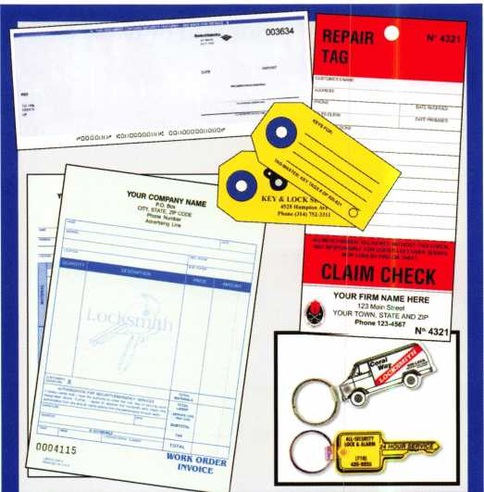

|  |  |  |
| --- | --- | --- |
| Professional Busi | | iness Products |
| Invoices | Tags | Call for a free |
| Checks | Key Fobs | brochure and samples |
| Business | Magnets | 1-800-355-6322 |
| Cards | Labels | [www.pbp2000.com](http://www.pbp2000.com) |

Keynotes • November 2007

Craft

your own career

in Locksmithing

Learn to be a locksmith at our conveniently  
scheduled hands-on morning program. Classes  
are given from 7:30 am - 12:30 pm. Over nine  
months you will learn to service, install and  
bypass a wide variety of locking devices including

residential, commercial and automotive locks. Master keying, electronic  
access, and safe manipulation round out a curriculum which is updated  
annually to incorporate the latest industry advancements. September and  
February admissions.

Other full-time courses offered are • Bookbinding • Cabinet & Furniture  
Making • Carpentry • Preservation Carpentry • Jewelry Making & Repair  
• Piano Technology • Violin Making & Repair

Financial aid is available for qualified students. Accredited member ACCSCT. Non-accredited workshops 1 week to 3 months also offered.

NORTH-BENNET-STREET-SCHOOL

AN EDUCATION IN CRAFTSMANSHIP 39 North Bennet St. • Boston, MA 02113 • (617) 227-0155

**[www.nbss.org](http://www.nbss.org)**

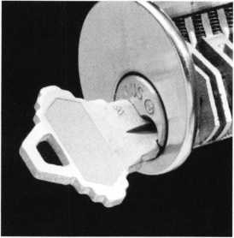

ALOA Expanding our Presence

ALOA continues to expand its presence  
both domestically and internationally.

We were represented at Pacific Security Conference, Institutional Locksmiths Associations annual convention, SER- LAC, GPLA and the International Fa­cilities Management Associations annual convention in October. Our representatives covered the country pro­viding education and information to other locksmiths and access control professionals on the purpose and mis­sion of our association.

ALOA’s headquarters and several local members’ hosted twenty-four lock­smiths from the People’s Republic of China representing the Locksmith Branch Department of China Security Association. Their delegation was led by Mr. Wu Longxie, Vice Chairman & Secretary-General and Ms. Wang Song, Director of the Secretariat. Their mis­sion is to advance professionalism and standardization within the industry in China. The China Security Association was officially formed in 2005 and cur­rently has 600 members in membership categories that are very similar to ALOA’s. According to the China Secu­rity Association, China has over 250,000 locksmiths and 3000 manu­facturers in their country.

The purpose of their visit was to strengthen ties between our two organ­izations via an exchange of market de­velopment and technology in the US and China including the advancement of professionalism, education and cer­tification within the locksmithing in­dustry worldwide.

During their two day visit, we toured Key Express, A-l Locksmith, Michael’s Keys Inc., Hans Johnsen Company, Se- curitex and Rolland Safe Company and held a panel discussion as an opportu­nity to exchange information on our in­dustry and theirs.

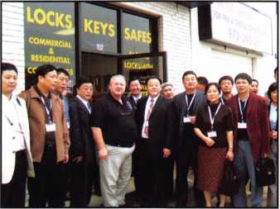

Key Express owned by John Arnold, CML has been in business for 20 years. John started out with an old pickup, toolbox and a Foley Belsaw machine. John also owns Securitex which dates back to the 1800’s. Because of this ac­quisition, John has many unique ma­chines, locks, literature and key blanks.

The Chinese delegation was fascinated by an old cash register that they thought was an old key cutting ma­chine.

John has been a member of ALOA for 23 years, served as the past president of the Associated Locksmiths of North Texas and is currently serving as the 1st Vice President of the Texas Locksmith Association. John believes that his in­volvement with associations has had a positive impact on his business as well as his trade.

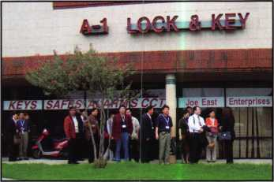

A-l Security, established in 1949 by Joe East’s grandfather and uncle has evolved into the most known and trusted secu­rity company in the North Texas area. They currently have five security cen­ters that stock and sell anything from keys to cameras and security systems. Their centers continue to be used has a business model for many locksmiths in the DFW metroplex and other cities and states.

**42**

Keynotes • November 2007

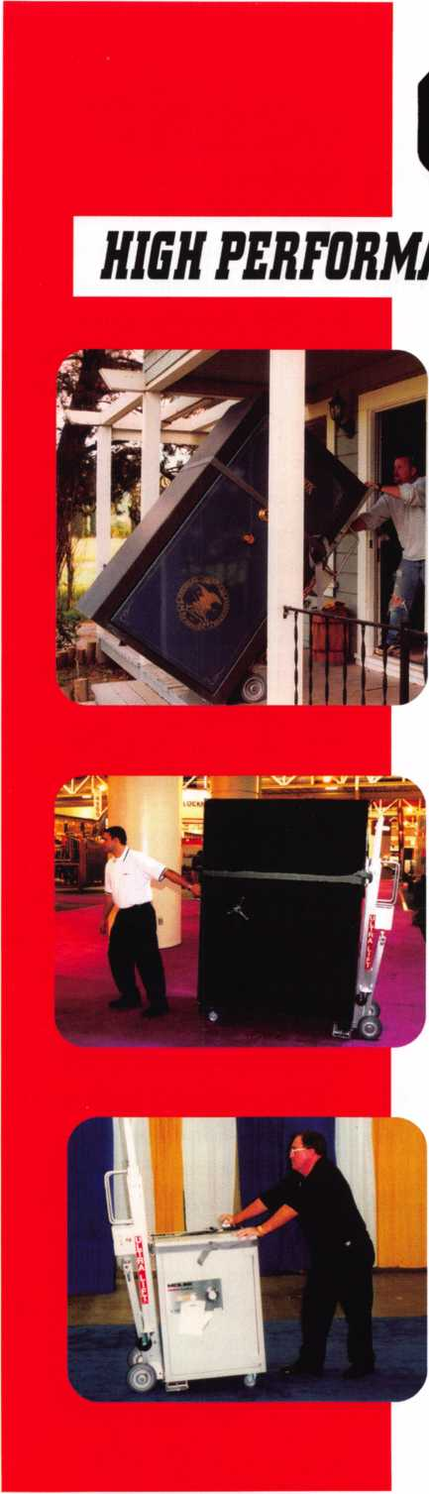

*OPERATOR SAFETY*

Injuries can be virtually eliminated. Ultra Lift does the lift­ing so that operator effort required to complete a move is minimized. Heavy loads are broken back with ease. The operator stays in control by using a combination of motor power, balance and leverage in every phase of a move.

*REDUCE LABOR COSTS*

Fewer people are required for any move with Ultra Lift. Manpower can be scheduled more productively. Labor savings often pay for the Ultra Lift in one month.

*ELIMINATE DAMAGE*

Loads are broken back, set down and moved under power with maximum leverage and operator control. Gentle handling eliminates bumps, bounces and damage to the load and premises.

*INCREASE PROFITS*

Increased operator safety, reduced labor cost and elimina­tion of damage to the load and premises all contribute to significant increases in profits.

FOR LITERATURE, VIDEO OR ON-SITE DEMONSTRATION, WRITE OR CALL:

ULTRA LIFT CORPORATION

475 STOCKTON AVENUE, UNIT E SAN JOSE, CA 95126 800346-3057 408-287-9400 FAX 408-297-1199 E-mail: [info@ultraIift.com](mailto:info@ultraIift.com) [www.ultralift.com](http://www.ultralift.com)

U.S. PATENT 4.570.953

ULTRA LIFT supplies the power — so you don't have to. One person can safely and easily handle loads that usually require 2 or 3 people, even up or down stairs. Two people can handle most safes to 1500 pounds. If safety is your concern, ULTRA LIFT is the best move you'll ever make!

Mr. East remains committed to the ed­ucation and certification of locksmith professionals. A-Is staff has over 200 years of locksmithing/access control ex­perience. Training classes are held every month at their corporate offices, in­cluding ALOA certified hours and in­structors.

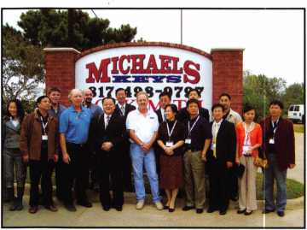

Michael’s Keys was established in Oc­tober of 1988, with William M. Lem­mon, his wife Carol and brother, Jerry. Michael has served has the President and Treasurer of the Metroplex Lock­smith Association. Michael’s Keys re­mains committed to education and holds monthly meetings and classes for the association at his shop.

Over the past 20 years their business has grown to include over 25 trucks and 43 employees who take pride in staying on top of the latest technologies in­cluding high security car keys with transponders, to high security safes with the latest locks.

Hans Johnsen Company was started in 1901 as a retail bicycle business and be­tween 1905 and 1906 became a whole­sale distributor of bicycle products. In the teens (1911 to 1919) they went into the wholesale automobile accessory

business and also cut duplicate keys and they went into the wholesale key blank distribution business.

During the 1930’s the company con­solidated their operation into the mower, locksmith and bicycle wholesale distribution business leaving the auto­mobile and other non-related indus­tries.

Today they have eight sales people in their locksmith division who personally contact customers in Texas, Louisiana, Arkansas, Western Missouri, Kansas, Oklahoma and New Mexico.

Rolland Safe Company founded over 100 years ago by the Rolland family in New Orleans, is one of the oldest and most knowledgeable national safe re­sources in the United States. Over the past century, the Rolland Safe Com­pany has evolved from a small regional family business into today’s full-service national safe company.

Rick Rolland has been a member of ALOA for more than 25 years and con­tinues to be a strong supporter of the association, and is part of the third gen­eration, operating their business.

Each of these visits provided the Chi­nese delegation an opportunity to learn new technologies, products and busi­ness practices that may help them with the development of their industry.

ALOA wishes to extend a special thank- you to David Peay, CRL and his wife Judy, owners of Locksmith Services of Tyler and their niece, Vida Huang for



acting as official ambassadors and trans­lators.

David started out in 1979 as a self- taught automotive locksmith working for wrecker services and recovery agents. He started Automotive Lock­smith of Tyler in 1986 with $115 worth of tools that his father bought at Can­ton, Texas trade-day, Curtis clippers, and a 1968 Chevy pickup. He then went on to purchase Anderson Lock­smith Service in 1994, Adams Safe and Lock in 1996. He also purchased AAA Lock and Safe in 1998, and finally Ac­tion Automotive in 2006. David is a member of TLA, ALOA, SAVTA, and DHL His wife Judy, a native of Tai­wan, is also a Texas licensed locksmith. Judy translated for the Chinese lock­smiths that came to visit. We would not been able to host such a successful event without their gracious assistance

We also wish to express our gratitude to C.D. Lipscomb, CML. CPS, ALOA’s Director, South Central Region, for all of his assistance in arranging the visits with our local members and to the members of our locksmith panel.

Panel members included: C.D. Lipscomb, CML, CPS, ALOAs Director; South Cen­tral Region; David Peay; CRL, owner of Locksmith Services of Tyler; Matt Agee, General Manager; A-l Locksmith; John Arnold, Owner, Key Express; Mike Lem­mon, Owner, Michaels Keys, Inc.; David Lowell, ALOAs Director of Education; Tim McMullen, ALOAs Legislative Manager

Keynotes • November 2007

Crossword by Myles Mellor



Welcome to our new depart-  
ment, the **Keynotes** monthly  
crossword puzzle.

Fax your completed puzzle by  
the 15th of December along  
with your name, member num-  
ber and address to Betty  
Southerland at 214-819-9736.  
Correct submissions will be en-  
tered into a drawing for a ter-  
rific ALOA prize. *You must be  
a current member to participate  
in the puzzle contest. (The so-  
lution to the puzzle will be  
printed in the next issue.)

Across

1. Devices to protect valuables
2. Money storage facilities

10. Overtime, for short

12. When the customer expects you (2 words)

14. Two piece housing encasing the upper

steering column and ignition lock in some cars

1. Type of card operated lock
2. Underlined, abbr.
3. Complete

20. Put the door back perhaps 22. Young horses 24. Knob or lever, for example 26. Time of arrival, hopefully

1. tool - used to read fault codes
2. Distance measurement for short
3. Type of lock or latch mounted on the surface of a door or drawer
4. A positive one is important 34. It gets locked often

Down

1. What a locksmith helps provide
2. Type of key used on the original Yale pin tumbler mortise locks
3. Emergency call
4. Internet provider
5. Open
6. Light, briefly
7. Mechanism preventing entry during certain periods (2 words)
8. card

11. Bad guy 13. For example

15. Increasingly popular form of security

1. IP

21. Turn down word 23. Gets into harmony with 25. Raleigh locale 27. It's better fresh!

1. Doctor, abbr.

001(0

**o>M**

Security Window

* Recognized & Accepted by the TSA
* Security Window cannot be altered with a paper clip
* Security Window can only be reset by a person knowing the combination
* Zinc Die Cast Body (Not Brittle Plastic)
* Steel Shackle is virtually unbreakable

**Red Window:**

Luggage has been searched.

**Green Window:**

1 Lock Not Opened.

*Styles &. Colors for t very Lifestyle*

**The name you can trust for  
travel safety, security & accountability.**

Protected by U.S. Patents 6,877,345 and 7,007,521. The Design of the Lock is a Registered Trademark® of The Eastern Company.



Security Products A Division of The Eastern Company **A Proud Union Company. (S.E.I.U.)** 301 West Hintz Road | Wheeling, IL 60090 | Telephone: 800.733.8588 | Fax: 847.537.1881 **[www.cclsecurity.com](http://www.cclsecurity.com)**



**TRAVEL SENTRY**

**APPROVED**



[www.schlage.com](http://www.schlage.com)

Real Security Is When Do-Overs  
Take Place Only On Your Personal Time.

When you install Schlage® locks, you know you've done the job right. After all, our products are among the most durable and dependable on the market today. They're also easy to install, repair and maintain, so they generate fewer callbacks. Which means you're free to concentrate on other things. Like learning how to pick up the 7-10 split.

Real Security Sets You Freer

*

t

l " •

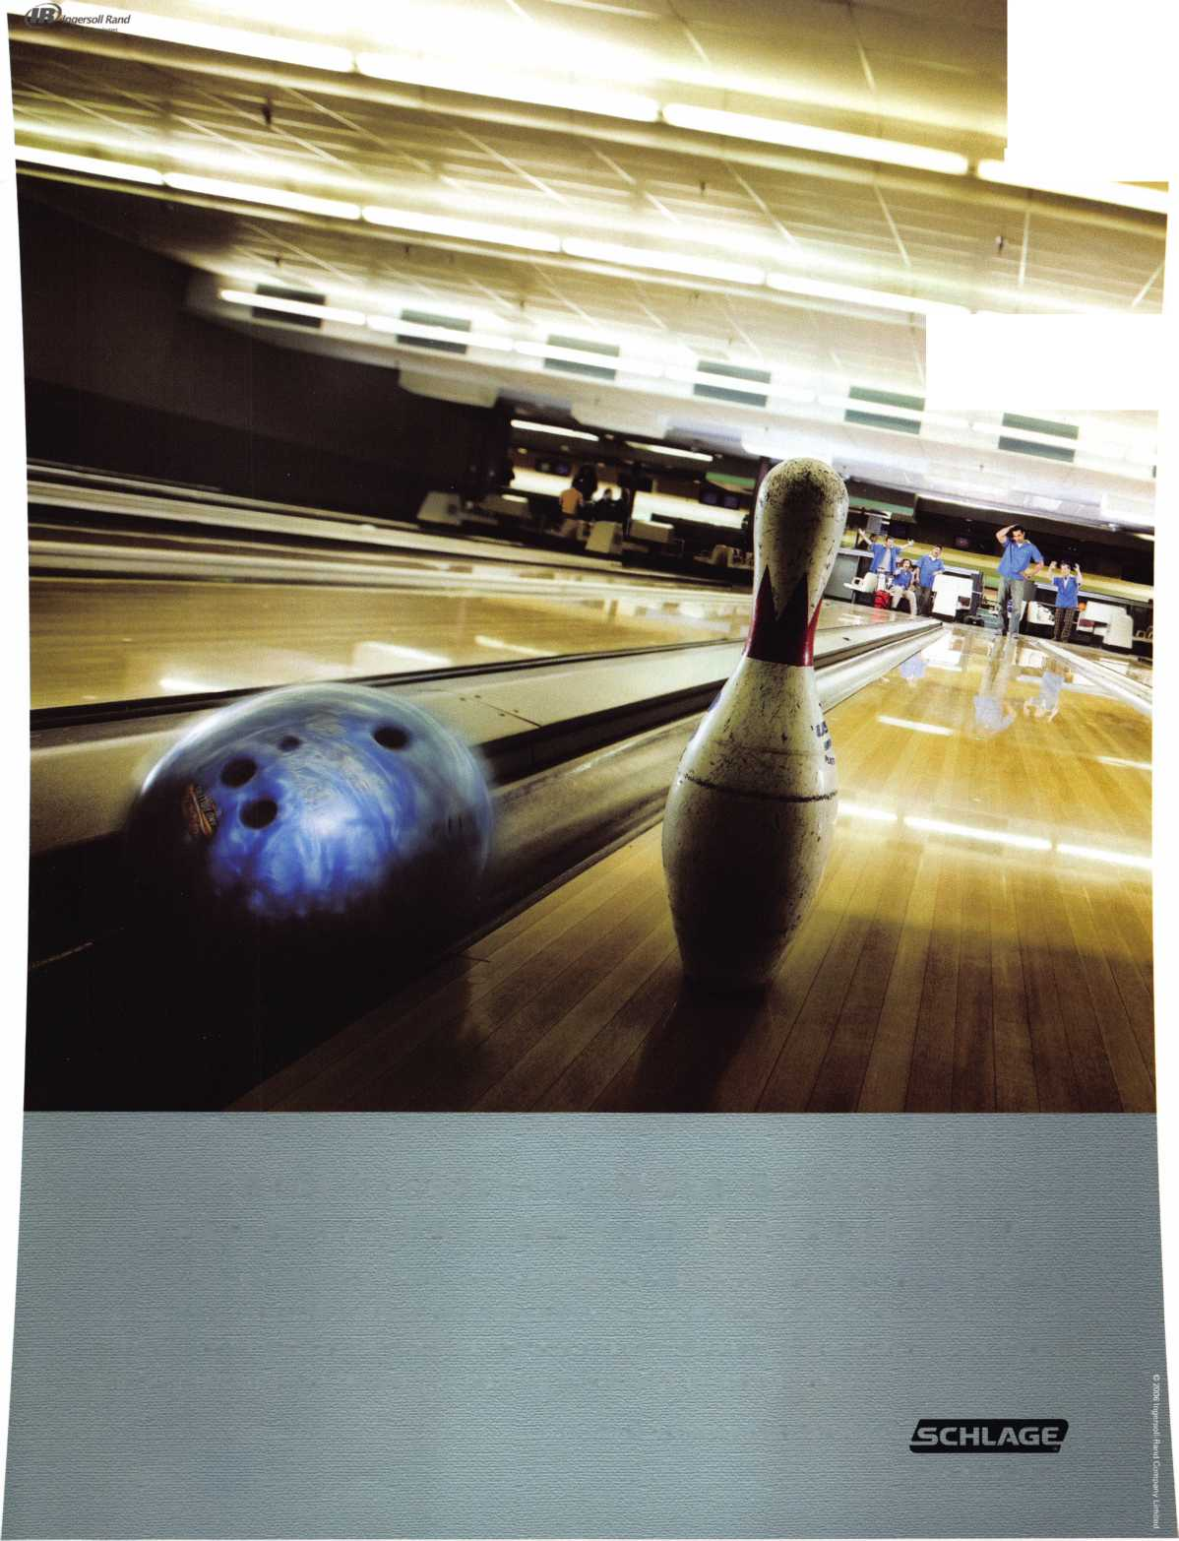

Northwest Region

Eligible to vote: Active, Apprentice,  
Retired, and Life members whose  
business address is in Alaska, Idaho,  
Oregon, Montana, Wyoming, APOSF,  
Washington, Alberta, British Columbia,  
Northwest Territories, Saskatchewan,

Yukon Territory

North Central Region

Eligible to vote: Active, Probationary,

Retired members whose business address is in Dakota, Wisconsin, Ontario, Manitoba, and Nunavut Territories

Northeast Region

Eligible to vote: Active, Apprentice, Retired,  
Life members whose business address is  
in Connecticut, Delaware, District of  
Columbia, Maine, Maryland, Massachus-  
sets, New Hampshire, New Jersey, New  
York, Ohio, Pensylvania, Rhode Island,  
Vermont, Virginia, West Viriginia, APONY,  
Quebec, Labrador, Newfoundland, Nova  
Scotia, New Brunswick, Prince Edward

Island

Southwest Region

Eligible to vote: Active, Probationary, Retired, and Life members whose business address is in Arizona, California, Colorado, Hawaii, Nevada, New Mexico, and Utah

South Central Region

Eligible to vote: Active, Apprentice,

Retired, Life members whose business address is in Arkansas, Kansas, Louisiana, Missouri,Oklahoma, and Texas

| Southeast Region

Eligible to vote: Active, Probationary, Retired, and Life members whose business address is in Alabama, Florida, Georgia, Kentucky, Mississippi, North Carolina, Puerto Rico, South Carolina, and Tennessee

International Region

Eligible to vote: Active, Apprentice,

Retired, and Life members whose business address is in any location other than the United States or Canada

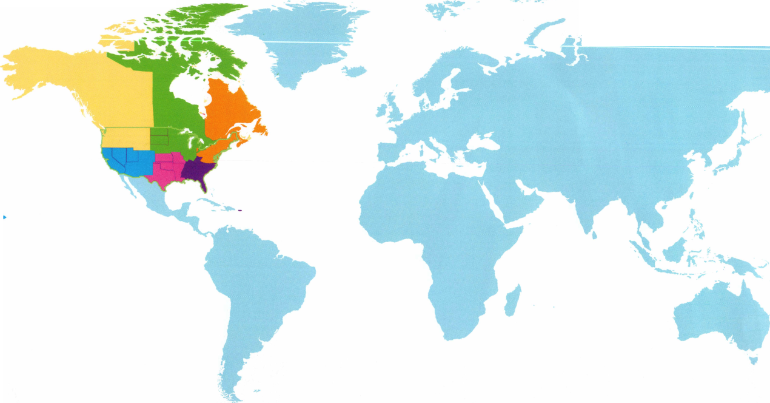

**Single Door Access Control**

ilfiffiit

Controller Only Version

ACCESS CONTROL SOLUTIONS

for over fifty years

With Built-in Card Reader

Up to 1000 card codes

3600 event transaction buffer

Timed anti-pass back

Four time zones

Print menu

Real time print mode

Built-in programming keypad

**DoorKing's model 1520 is a full feature economical single door access controller. The 1520 can be ordered with a built-in proximity card reader or as a controller only allowing you to add your own 26-bit wiegand device. The 1520 is ideal for single door access control in a variety of applications and provides outstanding features.**

**Call or visit our web site for more information!**

**Designing and Manufacturing a full line of product since 1948**

120 Glasgow Avenue, Inglewood, CA 90301 U.S.A. T: 310-645-0023 1-800-826-7493 F: 310-641 -1586 E-mail: [info@doorking.com](mailto:info@doorking.com) [www.doorking.com](http://www.doorking.com)

**Gate Operators**

**Parking Control**

**Telephone Entry**

**Member: AFA, DASMA, IDA, NOMMA, SIA, SSA**

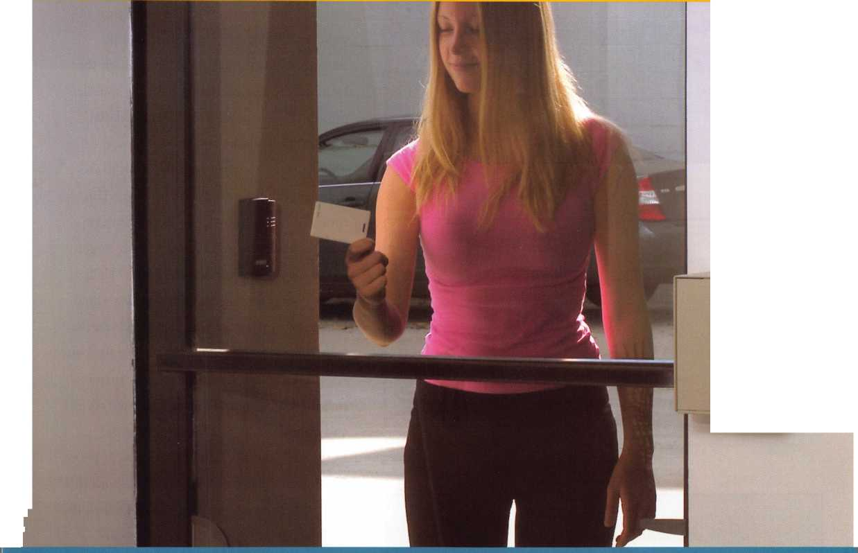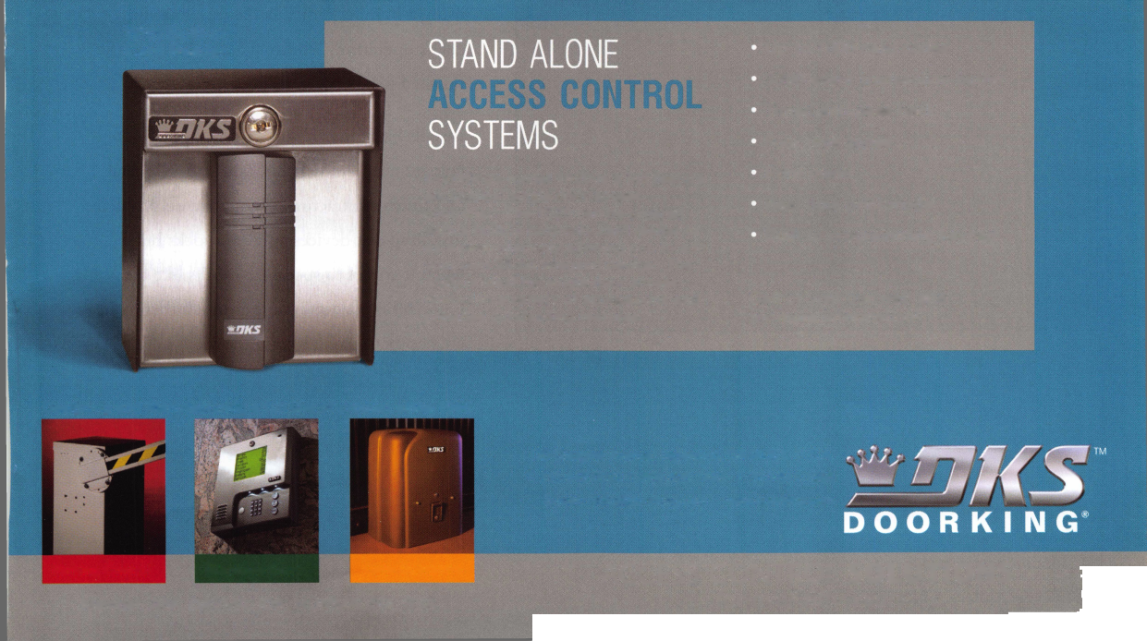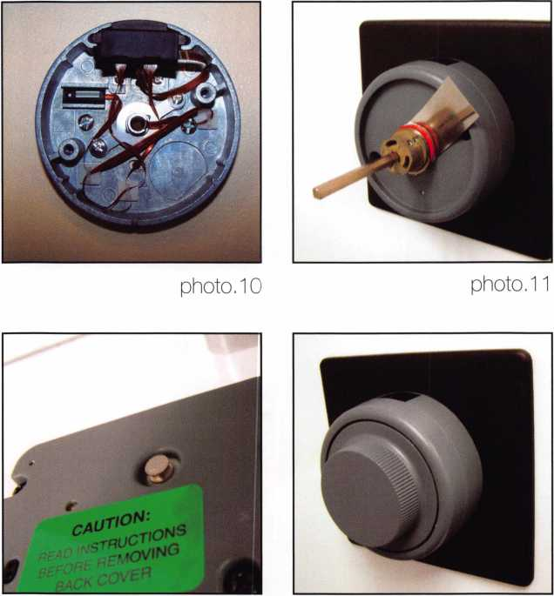

photo. 12 photo. 13

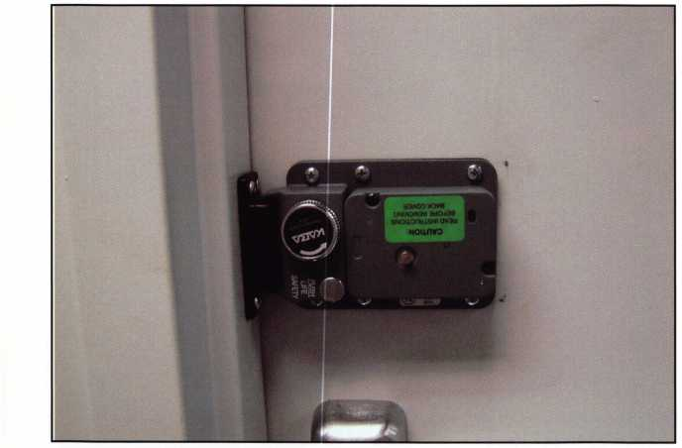

photo. 14

different wire routing methods, these are only two of the many ways possible. Once the wires are routed away from problem areas in­stall the dial ring cap. Insert the spindle through the drive cam and then through the lock body. Place the dial hub on the spindle, push it against the clearance shim and dial ring and then mark it for length, seen in photo 11. Remove the spindle, cut it to the right length, deburr it and reinstall it. This time use the lubricant provided to lubricate between the hub and dial ring. Don’t forget to use the shim for proper clearance. Tighten the two set screws against the spindle to hold it in place. Install the back cover and test the lock. Once it works a few times leave the bolt retracted and remove the back cover then in­stall the LOBC pin. Reinstall the back cover and extend the bolt. This should set the LOBC pin into the lock body as seen in photo 12. Install the dial and you are done with this part. Check operation with the strike then in­stall the balance of the screws. If you are using a number 3 or 9 strike install it and check operation. Photos 13 and 14 show the finished product.

Installs like this can come quite regularly if you are near a military installation. General and finish contractors might have no problem installing exit devices and door locks but when it comes to specialized locks like the CD-X09 most don’t want to touch them and are happy to pay for your knowledge.

■I Keynotes • November 2007

**BRIGHTEN** YOUR  
FUTURE. **HIGHLIGHT**YOUR SUCCESS!



& VAULT

TECHNICIANS ASSOCIATION CONVENTION & TRADE SHOW

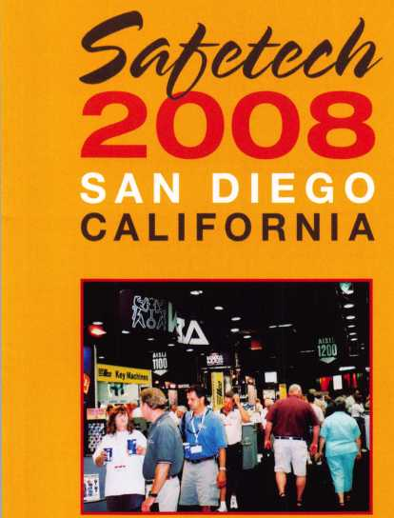

Highlight your path to the future with the latest technology the industry has to offer to safe technicians at SAFETECH 2008. Exposure to today’s top safe distributors and manufac­turers is absolutely crucial to making good purchasing and sales decisions. Additionally, time is of the essence when it comes to education. New de­velopments spring up each year, making top-notch safe

classes a necessity in our ever-changing environment. SAFETECH classes cover sub­jects related to the installation, maintenance and operation of sales and vaults at levels from novice to expert. The only chance to get world-class edu­cation and meet with the in­dustry’s top distributors and manufacturers is at the 2008 Safe & Vault Technicians Convention & Trade Show.

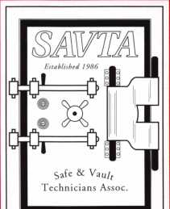

**SAFETECH 2008**

March 31-April 5, 2008  
Bahia Resort Hotel  
San Diego, California



[www.savta.org](http://www.savta.org) • 214.819.9771



BOARD

nominations

What ALOA Board Po­sitions Are Open and Where Am I Qualified to run?

There are currently six regional di­rector positions open for election in addition to the position of Secretary. ALOA members elect the directors from their own regions.

Only ALOA members from a region are eligible to run for the open posi­tion^) in that region. Only members from a nominee's region can vote for their regional candidates.

Members from any region can vote for the Secretary.

Candidates for director positions must have been active ALOA mem­bers for a minimum of three years to be eligible to run. Candidates for the office of Secretary must have also served on the Board within the prior three years to be eligible.

The following vacancies will exist for the election to be held before the ALOA 2008 Convention.

Secretary 1 position

Northeast 2 positions

South Central 1 position

Northwest 1 position

International 1 position

Associate 1 position

If you have any auestions, please contact Jonn Soderland at 414-327-5625 or e-mail [secretary@aloa.org](mailto:secretary@aloa.org).

On this page you will find the re­quired nomination petition and on the following page, the board com­mitment form.

The number of signatures required for each position is as follows:

Secretary 25

Northeast 18

South Central 6

Northwest 3

International 6

Associate 1

Associated Locksmiths of America, Inc.

Board of Directors Nomination Petition

Please print legibly or type. This form can be reproduced if needed.

I, the undersigned, request thatbe placed on

(name of nominee and member number)



the ballot for

for the election to be held at

(position for which individual is being nominated)

the special meeting of ALOA members to be held on May 9, 2008 or any adjournment thereof.

I am eligible to vote in the

region.



PRINTED NAME



PRINTED NAME



PRINTED NAME



PRINTED NAME



PRINTED NAME



PRINTED NAME



PRINTED NAME



PRINTED NAME



PRINTED NAME



PRINTED NAME

11

PRINTED NAME

12

PRINTED NAME



PRINTED NAME



PRINTED NAME



PRINTED NAME



PRINTED NAME



PRINTED NAME



PRINTED NAME



PRINTED NAME



PRINTED NAME

21

PRINTED NAME

22

PRINTED NAME



PRINTED NAME



PRINTED NAME



MEMBER #

MEMBER #

MEMBER #

MEMBER #

MEMBER #

MEMBER #

MEMBER #

MEMBER #

MEMBER #

MEMBER #

MEMBER #

MEMBER #

MEMBER #

MEMBER #

MEMBER #

MEMBER #

MEMBER #

MEMBER #

MEMBER #

MEMBER #

MEMBER #

MEMBER #

MEMBER #

MEMBER #

SIGNATURE

SIGNATURE

SIGNATURE

SIGNATURE

SIGNATURE

SIGNATURE

SIGNATURE

SIGNATURE

SIGNATURE

SIGNATURE

SIGNATURE

SIGNATURE

SIGNATURE

SIGNATURE

SIGNATURE

SIGNATURE

SIGNATURE

SIGNATURE

SIGNATURE

SIGNATURE

SIGNATURE

SIGNATURE

SIGNATURE

SIGNATURE

PRINTED NAME

MEMBER #

SIGNATURE

**Shattered**

I i

**Save Time, Make Money**

Repairing a broken doorjamb used to take hours. Now in less than an hour, you can fix broken jambs and help prevent repeat offenses. Stop giving good business away to your carpenter.

1 Hinge Shield

j Hinge Shields fit around the existing >r hinges and help prevent hinges from ng kicked in

> Door Shield

3 Door Shield reinforces the lock area of ! door and helps prevent the door from itting when kicked. Low profile model available in colors to match your locks

hamh Shield

e backbone of the system, the Jamb ield is a 48" long sleeve that wraps ound the lock side of the doorjamb, aking it extremely difficult to kick in. le Jamb Shield comes sizes to fit andard (5.5") and Universal (5" to 12")

:k spacing. Jamb and hinge shields

**Proven  
Protection  
Where it’s  
Needed Most**

**A unique system that  
reinforces the key strike  
points on entry doors  
and repairs damage  
from previous kick-ins**

**8-582-2294**

4- 4... J . ,UL O 1 /V1

Your Customers Need This

Current security products only alert homeowners that they have already been violated.

Your customers will actually be able to sleep secure the night after a break-in. Helps eliminate tenant initiated damage and secures vacant units for landlords.

This Will Change Your Business

* You should make $1,000 on every call that you answer with this product
* Calling a carpenter to fix shattered jambs costs you money
* This will help you sell more high-end deadbolts

• Dn vnu work with anv landlords?

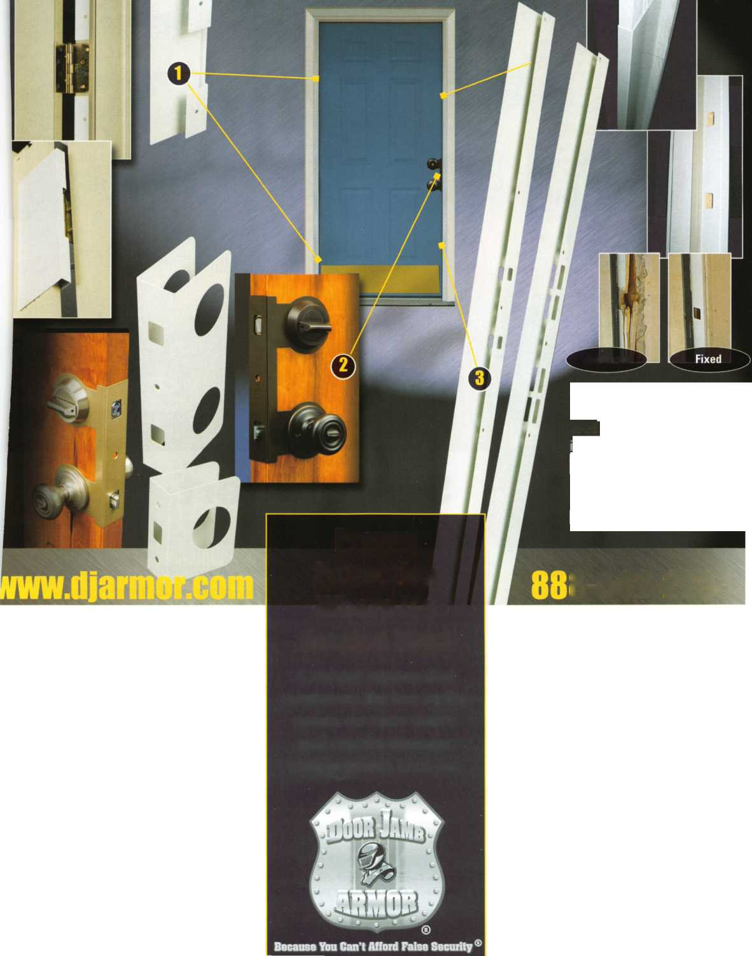

**SearchAlert**

* Available in a variety of colors and styles
* Recognized & Accepted by the TSA
* Security Window cannot be altered with a paper clip
* Security Window can only be reset by a person knowing the combination
* Zinc Die Cast Body (Not Brittle Plastic)
* Steel Shackle is virtually unbreakable

Security Window

O

**Red Window:**

Luggage has been searched.

O

**Green Window:**

Lock Not Opened.

The new SearchAlert Security window changes color from Green to Red when the TSA secured access device is used to open the lock, or when an unauthorized person has opened the lock using a counterfeit opening device. Travelers will now know when their SearchAlert Classic locks have been opened, and whether their bags have been searched by a TSA agent, or violated by an

unknown person. Protected by U.S. Patents 6,877,345 and 7,007,521. The Design of the Lock is a Registered Trademark9 of The Eastern Company.

*The name you can Trash for Travel safety, security accountability.*



**Security Products** A Division of The Eastern Company **A Proud Union Company. (S.E.I.U.)**301 West Hintz Road | Wheeling, IL 60090 | Telephone: 800.733.8588 | Fax: 847.537.1881  
**[www.cclsecurity.com](http://www.cclsecurity.com)**



**TRAUEL SENTRY**

**APPROVED**

